Introductory Mathematical Analysis, 14e, Global Edition (Haeussler et al.)
Chapter 1 Applications and More Algebra

1.1 Applications of Equations

Provide an appropriate response.

1) A company produces a product for which the variable cost per unit is $3.50 and fixed cost is $20,000 per year. Next year, the company wants the total cost to be $48,000. How many units of the product should be made next year?
Answer: 8000
Type: SA
Objective: (1) Applications of Equations

2) A company makes car stereos. The manufacturing cost for each stereo is $45. The company has fixed costs of $4150 per month. How many stereos can it make next month for a total cost of $10,000?
Answer: 130
Type: SA
Objective: (1) Applications of Equations

3) A certain machine can perform 34 chemical analyses per day, but a lab technician can perform only 7. Suppose a laboratory must make 110 analyses tomorrow and it has only two machines. How many technicians will be needed to complete the job?
Answer: 6
Type: SA
Objective: (1) Applications of Equations

4) The "current ratio" of a company is the value of its current assets divided by its current liabilities. A company has a current ratio of 2.5 and current liabilities of $80,000. what are its current assets?
Answer: $200,000
Type: SA
Objective: (1) Applications of Equations

5) The IQ (intelligence quotient) of a person is found by dividing his or her mental age by his or her chronological age and then multiplying that result by 100. For example, a person with a a mental age of 11 and a chronological age of 10 has an IQ of 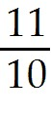 ∙ 100 = 110. Find the mental age of a person with a chronological age of 12 and an IQ of 125.
Answer: 15
Type: SA
Objective: (1) Applications of Equations

6) Approximately 21% of the air we breathe is oxygen. To the nearest milliliter, how many milliliters of air contain 1 milliliter of oxygen?
Answer: 5
Type: SA
Objective: (1) Applications of Equations
7) A company manufactures two types of prefabricated houses: ranch and colonial. Last year they sold three times as many ranch models as they did colonial models. If a total of 2640 houses were sold last year, how many of each model were sold?
Answer: 660 colonials, 1980 ranches
Type: SA
Objective: (1) Applications of Equations

8) A company manufactures hair dryers. The manufacturing cost is $9 per unit with a fixed cost of $16,000. A hair dryer sells for $15. If the company wants to earn a profit of $50,000, how many dryers must be sold?
Answer: 11,000
Type: SA
Objective: (1) Applications of Equations

9) The owner of a 20-room motel, which is 70% occupied, decides to charge $8 more than the single occupancy rate if two or more people occupy the room. This situation occurs in 75% of the occupied rooms, on the average. What should the two rates be so that the owner receives $160,000 in annual income to cover expenses and yield a reasonable profit? (Assume that a year has 365 days and give your answer to the nearest dollar.)
Answer: single rate, $25; rate for two or more people, $33
Type: SA
Objective: (1) Applications of Equations

10) A company is establishing a dental plan for its employees. Under this plan the company will pay the first $20 of an employee's dental-care expenses and 80% of all additional dental-care expenses up to a maximum total benefit payment of $700. For an employee, find the total dental-care expenses covered by this program.
Answer: $870
Type: SA
Objective: (1) Applications of Equations

11) An economics instructor told his class that the demand equation for a certain product is p = 400 - 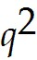 and its supply equation is p = 20q + 100. If the 400 - is set equal to the 20q + 100, then the positive solution to the resulting equation gives the "equilibrium quantity." The instructor asked his class to find this quantity. What answer should the class give?
Answer: q = 10
Type: SA
Objective: (1) Applications of Equations

12) A sociologist is hired by a city to study different programs that aid the education of preschool-age children. The sociologist estimates that n years after the beginning of a particular program, p thousand preschoolers will be enrolled, where p = 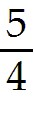n(12 - n). How many years after the start of the program will 25,000 preschoolers first be enrolled?
Answer: 2
Type: SA
Objective: (1) Applications of Equations

13) The product of two consecutive integers is 42. Find the integers.
Answer: 6 and 7, or -7 and -6
Type: SA
Objective: (1) Applications of Equations
14) The sum of a number and its square is 12. Find the number.
Answer: -4 or 3
Type: SA
Objective: (1) Applications of Equations

15) A rectangular plot, 4 meters by 8 meters, is to be used for a garden. The owner decides to put a pavement of uniform width inside the entire border so that 12 square meters of the plot is left for flowers. How wide should the pavement be?
Answer: 1 m
Type: SA
Objective: (1) Applications of Equations

16) A person deposits $50 in a bank and in two years it increases to $56.18. If the bank compounds interest annually, what annual rate of interest does it pay?
Answer: 6%
Type: SA
Objective: (1) Applications of Equations

17) Researchers at a university need a 10,000 square meter rectangular plot on which to grow three hybrids of corn. The plot is to be enclosed by fencing and divided into three equal subplots by a pair of fences both parallel to the same pair of sides of the rectangle. If 600 meters of fencing are to be used for the project, what are the dimensions of the plot?
Answer: 50 m by 200 m, or 100 m by 100 m
Type: SA
Objective: (1) Applications of Equations

18) A theater owner charges $3 for each ticket. Currently, only 100 people attend the theater daily. The owner believes that for each $0.10 decrease per ticket, 10 more people will attend. If this is true and the capacity of the theater is 200, what should the price of a ticket be if the owner wants to receive $375 daily from ticket sales?
Answer: $2.50
Type: SA
Objective: (1) Applications of Equations

19) One of the most important defoliating insects is the gypsy moth caterpillar, which feeds on foliage of shade, forest, and fruit trees. A homeowner lives in an area in which the gypsy moth has become a problem. She wishes to spray the trees on her property before more defoliation occurs. She needs 128 ounces of a solution made up of 3 parts of insecticide A and 5 parts of insecticide B. The solution is then mixed with water. How many ounces of insecticide A should be used?
A) 16
B) 38.4
C) 48
D) 52
E) 68
Answer: C
Type: MC
Objective: (1) Applications of Equations
20) A good oiled furniture finish contains two parts boiled linseed oil and one part turpentine. If you need a pint (16 fluid ounces) of this furniture finish, how many fluid ounces of turpentine are needed?
A) 2
B) 3
C) 3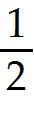
D) 4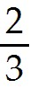
E) 5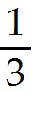
Answer: E
Type: MC
Objective: (1) Applications of Equations

21) An electric utility company is going to locate its new power plant along a straight road connecting the towns of Exton and Whyton, which are 10 miles apart. For political reasons, the utility company will buy coal from both towns. The price of coal per ton from Exton is $72.65 plus $0.45 per mile for delivery. The price per ton from Whyton is $72.25 plus $0.25 per mile for delivery. How far (in miles) from Exton should the plant be located if the price of coal per ton delivered from Exton is to be equal to that from Whyton? (Hint: If d is the distance of the plant from Exton, then 10 - d is the distance from Whyton.)
A) 2
B) 3
C) 3
D) 4
E) 6
Answer: B
Type: MC
Objective: (1) Applications of Equations

22) Suppose consumers purchase q units of a manufacturer's product when the price per unit (in dollars) is 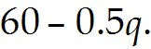 If no more than 75 units can be sold, then the number of units that must be sold in order that sales revenue be $1000 is
A) 20.
B) 25.
C) 40.
D) 50.
E) 75.
Answer: A
Type: MC
Objective: (1) Applications of Equations
23) A group of biologists studied the nutritional effects on rats that were fed a diet containing 10% protein. The protein was made up of yeast and corn flour. By changing the percentage P (expressed as a decimal) of yeast in the protein mix, the group estimated that the average weight gain g (in grams) of a rat over a period of time was given by g = 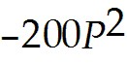 + 200P + 20. What percentage of yeast gave an average weight gain of 70 grams?
A) 50%
B) 60%
C) 65%
D) 70%
E) 80%
Answer: A
Type: MC
Objective: (1) Applications of Equations

24) A company will enclose a rectangular area of 12,800 square feet in the rear of its plant. One side will be bounded by the building and the other three sides by fencing. Suppose that 400 feet of fencing will be used and that the side of the building has a length of 100 ft. What will be the dimension (in feet) of the side of the rectangle that is opposite the building?
A) 20
B) 40
C) 60
D) 80
E) 90
Answer: D
Type: MC
Objective: (1) Applications of Equations

25) Imperial Educational Services (I.E.S.) wants to offer a workshop in pollution control to key personnel at Acme Corporation. I.E.S. will offer the course to thirty persons at a charge of $50 each. Moreover, I.E.S. will agree to reduce the charge for everybody by $1.00 for each person over the thirty who attends, up to a total group size of fifty. It has been determined that the greatest revenue the I.E.S. can receive is $1600. What group size will give this revenue?
A) 34
B) 36
C) 40
D) 44
E) 48
Answer: C
Type: MC
Objective: (1) Applications of Equations

26) The sum of 3 integers is 27. The second is 3 more than the first, and the third is two more than twice the second integer. Find the three integers.
Answer: 4, 7, 16
Type: SA
Objective: (1) Applications of Equations

27) A rectangular field is twice as long as it is wide. Find the dimensions of the field if it needs 600 feet of fencing to go around the field.
Answer: 200 × 100
Type: SA
Objective: (1) Applications of Equations
28) The sum of two integers is 21. The second integer is three more than twice the first integer. Find both of the integers.
Answer: 6, 15
Type: SA
Objective: (1) Applications of Equations

29) An elder brother is twice as old as his younger brother at the present. Six years ago the elder brother was three times as old as the younger brother. Find the present age of the brothers.
Answer: 12, 24
Type: SA
Objective: (1) Applications of Equations

30) A company produces and sells q units of its product. If the variable cost is $4/unit, fixed costs are $4800 and the selling price is $28/unit, find the number of units the company must produce to split even (i.e., zero profit).
Answer: 200 units
Type: SA
Objective: (1) Applications of Equations

31) A person wishes to deposit a total fo $10,000 in two accounts. The savings account pays yearly interest of 4% and fixed certificates of deposit pay a yearly interest rate of 7%. How much should the person deposit in each account so that he gets a total of $502 interest at the end of the year?
Answer: Savings Account = 6600
Certificate of Deposit = 3400
Type: SA
Objective: (1) Applications of Equations

32) The sum of two real numbers is 12. The sum of their reciprocals is . Find the two numbers.
Answer: 6, 6
Type: SA
Objective: (1) Applications of Equations

33) A bank loaned $3320 to a company for the development of two products. If the loan for product A was $1520 more than the other, how much was loaned for each product?
Answer: 900, 2420
Type: SA
Objective: (1) Applications of Equations

34) A chef must prepare 10 cups of a sauce. The recipe calls for 1 part wine and 4 parts beef stock. How much of each ingredient should be used?
Answer: 2 cups wine and 8 cups beef stock
Type: SA
Objective: (1) Applications of Equations
35) A baker must prepare 6 cups of pie filling. The recipe calls for cup of sugar for each 4 cups of fruit. How much of each ingredient should be used?
Answer: cup of sugar and 5 cups of fruit
Type: SA
Objective: (1) Applications of Equations

36) A chemist must prepare 540 ml of a chemical solution. It is to be made up of 4 parts acid and 5 parts distilled water. How much of each should be used?
Answer: 240 ml of acid and 300 ml of water
Type: SA
Objective: (1) Applications of Equations

37) A metallurgist is preparing 63 kg of an alloy. It must consist of 3 parts aluminum and 4 parts copper. How much of each metal should be used?
Answer: 27 kg aluminum and 36 kg copper
Type: SA
Objective: (1) Applications of Equations

38) A homeowner needs to make a cover for a circular pool with a diameter of 18 feet. How much cover fabric should be ordered if the cover must extend 2 feet beyond the edge of the pool? (Hint: The area A of a circle is 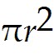, where r is the radius. Assume π = 3.14, and round to the nearest square foot.)
Answer: 380 sq ft
Type: SA
Objective: (1) Applications of Equations

39) A flower border of uniform width is to be added to a rectangular lawn, 30 feet by 40 feet. How wide should the border be so that 600 sq ft of lawn remains?
Answer: 5 ft wide
Type: SA
Objective: (1) Applications of Equations

40) A rectangular deck attached to a ski lodge is 22 m long and 10 m wide. Planter boxes will be added along the 3 open sides, which include 1 long side and both short sides. How wide can the boxes be to leave 180 sq m of deck space?
Answer: 1 m wide
Type: SA
Objective: (1) Applications of Equations

41) A fence is to be placed around a rectangular plot so that 2700 sq ft are enclosed. How much fencing must be used if the plot is 3 times as long as it is wide?
Answer: 240 ft
Type: SA
Objective: (1) Applications of Equations
42) A company's revenue from the sale of interior doors is $98 per door. The cost of producing the doors is $48 per door with $12,000 in fixed costs. How many doors must the company sell in order to break even?
Answer: 240 doors
Type: SA
Objective: (1) Applications of Equations

43) A car dealer has 20 new automobiles which she purchased for $12,000 each. If she sells 16 of them at a profit of 20%, for how much must she sell the remaining 4 to have an average profit of 18%?
Answer: $13,200
Type: SA
Objective: (1) Applications of Equations

44) A painting contractor completed two jobs at $480 each. For one of them, this represented a 20% loss; for the other it was a 20% profit (based on his cost for each job). How much did he make or lose on the two jobs?
Answer: Lost $40
Type: SA
Objective: (1) Applications of Equations

45) An appliance company makes coffee makers for which the variable cost per unit is $12 and the fixed cost is $92,000. What should the selling price be for the company to earn a profit of $88,000 on 10,000 units?
Answer: $30
Type: SA
Objective: (1) Applications of Equations

46) A bicycle costs a wholesaler $63 and the wholesale selling price includes a markup of 25% of the wholesale selling price. What should be the retailer's selling price in order to make a profit of 30%
Answer: $109.20
Type: SA
Objective: (1) Applications of Equations

47) A kitchen cabinet maker wants to establish a list price for a standard cabinet so that the selling price gives a trade discount of 10% of the list price. If he makes a markup of 20% of the selling price, and his cost is $144, what list price should he charge?
Answer: $200
Type: SA
Objective: (1) Applications of Equations

48) A recliner costs a wholesaler $189 and her markup is 10% of her selling price. If the retailer's markup is 30% of his selling price for the item, what is the retailer's selling price?
Answer: $300
Type: SA
Objective: (1) Applications of Equations
49) A computer keyboard retails for $48.54, which includes a markup of 40% for the retailer and a markup of 20% for the wholesaler. What did the keyboard cost the wholesaler?
Answer: Approximately $28.89
Type: SA
Objective: (1) Applications of Equations

50) A woman has $90,000 to invest in two mutual funds. One fund is low-risk and has an annual yield of 10%. The second fund is medium-risk and has a 15% annual yield. How much should she invest in each fund if she would like to earn $10,000 per year from her investments?
Answer: $70,000 in the low-risk fund and $20,000 in the medium-risk fund
Type: SA
Objective: (1) Applications of Equations

51) A retired couple has $192,000 to invest. A safe investment yields 9.5% per year, but a riskier investment yields 12.5% per year. How much should they invest at each rate to earn $21,000 per year?
Answer: $100,000 in the safe investment and $92,000 in the riskier investment
Type: SA
Objective: (1) Applications of Equations

52) A father wants to invest $50,000 in order to earn $4000 per year to help pay for his daughter's college education. He places $30,000 in a savings account earning 5% per year. He wants to place the rest of his investment in a mutual fund. How much will the mutual fund have to earn for him to make his goal?
Answer: 12.5%
Type: SA
Objective: (1) Applications of Equations

53) A teenager has $10,000 invested in a checking account paying 2.5% per year and a savings account paying 6.5% per year. The total interest earned in the two accounts at the end of the year was equivalent to an annual rate of 6% on the entire $10,000. How much was invested in each account?
Answer: $1250 in the checking account and $8750 in the savings account.
Type: SA
Objective: (1) Applications of Equations

54) A county decides to retire some of its road construction bonds in 2 years. At that time $4,840,000 will be required. If it presently sets aside $4,000,000, at what annual rate of interest, compounded annually, will this money need to earn in order for its future value to be sufficient to retire the bonds?
Answer: 10%
Type: SA
Objective: (1) Applications of Equations

55) A biotech company will require $10,112,400 to expand its research facility in 2 years. It has $9,000,000 to invest now for this purpose. At what annual rate of interest, compounded annually, should it invest this amount to be ready for construction in 2 years?
Answer: 6%
Type: SA
Objective: (1) Applications of Equations
56) A corporation plans to buy back some of its stock in 2 years for $1,081,600. It plans to invest $1,000,000 this year to have the necessary capital for this move. At what annual rate of interest, compounded annually, should it invest this million dollars to earn enough for its stock re-purchase?
Answer: 4%
Type: SA
Objective: (1) Applications of Equations

57) A homeowner will need $37,632 in 2 years to pay off a balloon mortgage on her house, but she has only saved $30,000 so far. At what annual interest rate, compounded annually, should she invest her savings in order to pay off her mortgage in 2 years?
Answer: 12%
Type: SA
Objective: (1) Applications of Equations

58) A 100 unit high-rise apartment building which has no vacancy has come under new management. The new management company wants to receive $101,500 in monthly rent. They estimate that for each $50 per month increase over the current $950 per month rent, there will be three vacancies with no possibility of filling them. What rent should they charge for each apartment?
Answer: $1166.67 or $1450
Type: SA
Objective: (1) Applications of Equations

59) The owner of an 85 unit apartment building must raise the rent to cover an increase in property taxes of $9000 per year. At the current rent of $600 per month, each $30 per month increase will create one vacancy with no possibility of filling it. By how much should he raise the rent for these apartments?
Answer: $150 or $1800
Type: SA
Objective: (1) Applications of Equations

60) Rooms in a 130 unit student housing complex are fully rented at $300 per month. The university is raising rates to produce $1920 more in monthly income from these units. Each $10 per month increase will create two vacancies with no possibility of filling them. What should be charged for the new rent?
Answer: $330 or $620
Type: SA
Objective: (1) Applications of Equations

61) An office complex consists of 300 units which rent at $760 per month with no vacancies. Each $20 per month increase will create four vacancies with no possibility of filling them. The owner wishes to receive $233,600 per month from the complex. How much should the rent be increased to meet this goal?
Answer: $40 or $700
Type: SA
Objective: (1) Applications of Equations
1.2 Linear Inequalities

Provide an appropriate response.

1) Solve: 7 - 2x < 9
Answer: x > -1
Type: SA
Objective: (1) Linear Inequalities

2) Solve: 5x - 2 ≥ 14 - 3x
Answer: x ≥ 2
Type: SA
Objective: (1) Linear Inequalities

3) Solve: 4x - 3 < -2(1 - x)
Answer: x <
Type: SA
Objective: (1) Linear Inequalities

4) Solve: 3(4x - 1) ≥ 2(x + 4)
Answer: x ≥
Type: SA
Objective: (1) Linear Inequalities

5) Solve: -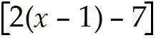 ≤ 9x - (3 - x)
Answer: x ≥ 1
Type: SA
Objective: (1) Linear Inequalities

6) Solve: 2(x - 8) + 5 ≤ -4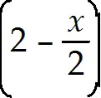
Answer: -∞ < x < ∞
Type: SA
Objective: (1) Linear Inequalities

7) Solve: z - 2 ≥ 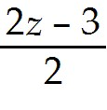
Answer: no solution
Type: SA
Objective: (1) Linear Inequalities

8) Solve: 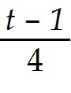 + 3 > 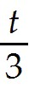
Answer: t < 33
Type: SA
Objective: (1) Linear Inequalities
9) Solve: 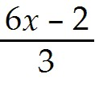 ≤ - 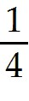
Answer: x ≤ 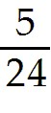
Type: SA
Objective: (1) Linear Inequalities

10) Solve: 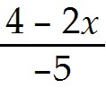 > x + 2
Answer: x < - 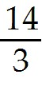
Type: SA
Objective: (1) Linear Inequalities

11) The solution of 5x >2x is
A) x > 0
B) x < 0
C) x <
D) x > -3
E) -∞ < x < ∞
Answer: A
Type: MC
Objective: (1) Linear Inequalities

12) The solution of 2(4 - 3x) ≥ 10 + 4(x + 1) is
A) x ≥ 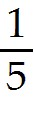
B) x ≥ -
C) x ≤ - 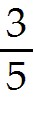
D) x ≥
E) x ≥ 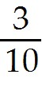
Answer: C
Type: MC
Objective: (1) Linear Inequalities
13) The solution of 3x - 5 ≥ x - (4 - 2x) is
A) x ≥ 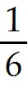
B) x ≤ -
C) x ≥
D) no solution
E) -∞ < x < ∞
Answer: D
Type: MC
Objective: (1) Linear Inequalities

14) The solution of 3 - 4(x + 5) < 3x + 7(4 - x) is
A) x < - 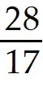
B) x >
C) x < 45
D) no solution
E) -∞ < x < ∞
Answer: E
Type: MC
Objective: (1) Linear Inequalities

15) The solution of -2(x - 3) < x is
A) -∞ < x < ∞
B) x < -2
C) x > -2
D) x > 2
E) x < 2
Answer: D
Type: MC
Objective: (1) Linear Inequalities
16) The solution of 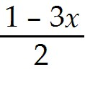 > 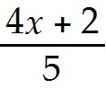 is
A) x > 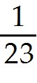
B) x <
C) x > -
D) x < -
E) x < 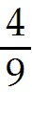
Answer: B
Type: MC
Objective: (1) Linear Inequalities

17) The solution of 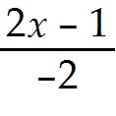 < 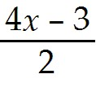 is
A) x < -
B) x >
C) x <
D) x > 1
E) x< 1
Answer: B
Type: MC
Objective: (1) Linear Inequalities

18) The solution of 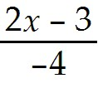 ≤ 2 - 7x is
A) x ≤ 1
B) x ≥ 1
C) x ≤ 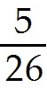
D) x ≥
E) ∅
Answer: C
Type: MC
Objective: (1) Linear Inequalities

19) Solve: 0.2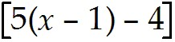 < 0.8(x + 1)
Answer: x < 13
Type: SA
Objective: (1) Linear Inequalities
20) Solve: 0.3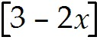 ≥ 4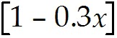
Answer: x ≥ 5.167
Type: SA
Objective: (1) Linear Inequalities

21) Solve: 3(x - 5) + 7 < 4(3 - x) + 7x - 20
Answer: no solution
Type: SA
Objective: (1) Linear Inequalities

22) Solve: 11(3 - x) + 2 ≤ 2(3 - 5x) + 29 - x
Answer: -∞ < x < ∞
Type: SA
Objective: (1) Linear Inequalities

23) Solve: (1 - 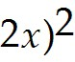 - 4(3 - 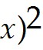 ≥ 5
Answer: x ≥ 2
Type: SA
Objective: (1) Linear Inequalities

24) Solve: 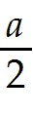 - 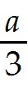 < 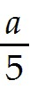 + 1
Answer: a > -30
Type: SA
Objective: (1) Linear Inequalities

25) Two resistors 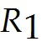 and 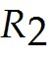 are connected in parallel in an electrical circuit. The net resistance R is given by 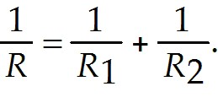 If = 20 ohms, what values of will create a net resistance of less than 10 ohms?
Answer: < 20 ohms
Type: SA
Objective: (1) Linear Inequalities

The 1996 tax brackets for a single person are given in the following table.
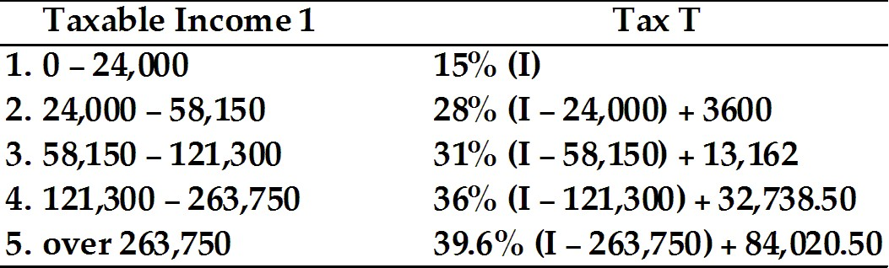
Source: 1040 Forms and Instructions, IRS, 1996

26) Write the income range for line 1 as an inequality. Write the inequality that represents the tax owed.
Answer: 0 ≤ I ≤ 24,000; 0 ≤ T ≤ 3600
Type: SA
Objective: (1) Linear Inequalities
27) Write the income range for line 2 as an inequality. Write the inequality that represents the tax owed.
Answer: 24,000 < I ≤ 58,150; 3600 < T ≤ 13,162
Type: SA
Objective: (1) Linear Inequalities

28) Write the income range for line 3 as an inequality. Write the inequality that represents the tax owed.
Answer: 58,150 < I ≤ 121,300; 13,162 < T ≤ 32,738.50
Type: SA
Objective: (1) Linear Inequalities

29) Write the income range for line 5 as an inequality. Write the inequality that represents the tax owed.
Answer: I > 263,750; T > 84,020.50
Type: SA
Objective: (1) Linear Inequalities

A zoo veterinarian can purchase 4 different animal foods with various nutrient values for the zoo's grazing animals. Let 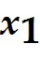 represent the number of bags of food 1, 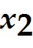 represent the number of bags of food 2, and so on. The number of bags of each food needed can be described by the following:
= 150 - 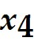 ≥ 0
= 3 - 210 ≥ 0
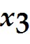 = + 60 ≥ 0

30) Solve each inequality for 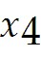.
Answer: ≤ 150
≥ 70
≥ -60
Type: SA
Objective: (1) Linear Inequalities

31) Determine an interval for that satisfies all of these inequalities.
Answer: 70 ≤ ≤ 150
Type: SA
Objective: (1) Linear Inequalities

32) Develop an interval for each of the other variables.
Answer: 0 ≤ 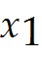 ≤ 80; 0 ≤ 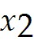 ≤ 240; 130 ≤ 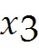 ≤ 210
Type: SA
Objective: (1) Linear Inequalities
Provide an appropriate response.

33) Hooke's Law of springs states that the force F (in pounds) required to stretch a spring x inches beyond its natural length is F = kx, where k is the "spring constant" for a given spring. If a certain spring has a spring constant k of 6.5 and 13 ≤ F ≤ 26, what are the corresponding values for x?
Answer: 2 ≤ x ≤ 4
Type: SA
Objective: (1) Linear Inequalities

34) Ohm's Law in electrical theory states that V = IR, where R is the resistance (in ohms) of an object, V is the potential difference (in volts) across the object, and I is the current (in amperes) that flows through it. If the voltage is 220 volts, what values for the current will result in a resistance that is less than 20 ohms?
Answer: I > 11 amps
Type: SA
Objective: (1) Linear Inequalities

1.3 Applications of Inequalities

Provide an appropriate response.

1) A company produces a product at a cost of $6 per unit. If fixed costs are $20,000 and each unit sells at $8, at least how many units must be sold in order to earn a profit?
Answer: 10,001
Type: SA
Objective: (1) Applications of Inequalities

2) A manufacturer has 4000 units of product x in stock and is now selling it at $10 per unit. Next month the unit price will increase by $2. The manufacturer wants the total revenue received from the sale of the 4000 units to be no less than $45,000. What is the maximum number of units that can be sold this month?
Answer: 1500
Type: SA
Objective: (1) Applications of Inequalities

3) Suppose a company offers you a sales position with your choice of two methods of determining your yearly salary. One method pays $15,000 plus a bonus of 3% of your yearly sales. The other method pays a straight 13% commission of your sales. For what yearly sales level is it better to choose the first method?
Answer: yearly sales under $150,000
Type: SA
Objective: (1) Applications of Inequalities
4) A company will manufacture a total of 5000 units of its product at plants A and B. At plan A the unit cost for labor and material combined is $2.50, while at plant B it is $3.00. The fixed costs at plant A are $6000 and at plant B they are $8000. Between the two plants the company has decided to allot no more than $28,000 for total costs. The minimum number of units that must be produced at plant A is
A) 1871.
B) 2000.
C) 2500.
D) 2545.
E) 2546.
Answer: B
Type: MC
Objective: (1) Applications of Inequalities

5) The "current ratio" of a company is the ratio of its current assets to its current liabilities. Suppose a company has current assets of $250,000 and current liabilities of $100,000. If the company wants to make a short-term loan and have their current ratio no less than 2.2, what is the maximum amount it can borrow? (Note: The funds they receive are considered as current assets and the loan as a current liability.)
A) $15,000
B) $20,000
C) $25,000
D) $30,000
E) $33,000
Answer: C
Type: MC
Objective: (1) Applications of Inequalities

6) Suppose a person has $23 in his pocket. What is the maximum number of pizzas that person can order if each pizza costs $4.39?
Answer: 5
Type: SA
Objective: (1) Applications of Inequalities

7) The relationship between Fahrenheit and Celsius temperature is given by the formula 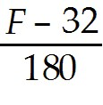 = 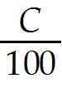. Normal body temperature is F ≥ 98.6. Find the corresponding Celsius temperature.
Answer: C ≥ 37
Type: SA
Objective: (1) Applications of Inequalities

8) A student receives grades of 63, 75, 66 in three midterms (out of 100 points). The final exam is worth 200 points. The student needs at least 70% to get a grade of C in the course. How many points, at least, must the student obtain (out of 200 points) to get a grade of C?
Answer: 146
Type: SA
Objective: (1) Applications of Inequalities
9) A company manufactures water filters that cost $15 for labor and material, plus $50,000 in fixed costs. If they sell the water filter for $20, how many must be sold to make a profit?
Answer: at least 10,000 filters
Type: SA
Objective: (1) Applications of Inequalities

10) A pet food company needs to calculate how much to charge for a bag of rabbit food that costs $10 to produce. The fixed costs involved in production are $15,000. They want to start making a profit after they have sold 4,000 bags of rabbit food. What is the least amount they can charge to make this goal?
Answer: $13.75 per bag
Type: SA
Objective: (1) Applications of Inequalities

11) A company produces plastic parts for automobiles. The manufacturing process for one part costs $28 per part for labor and material, plus $36,000 in fixed costs. Industry competition dictates that they can charge no more than $42 for this part. How much should they reduce the material and labor costs to satisfy a company policy of earning a profit after selling 2,000 units?
Answer: $4
Type: SA
Objective: (1) Applications of Inequalities

12) An electronics company manufactures personal CD players which sell for $89. If the production line has $81,000 in fixed costs and $44 per player in labor and materials, how many must they sell to make a profit?
Answer: 1800 players
Type: SA
Objective: (1) Applications of Inequalities

13) A homeowner must decide whether to buy or rent a garden rototiller. If she rents the machine, the rental fee is $25 per day, and the daily cost to use it is $5 for gas. If she were to buy the machine, the purchase price is $650, and the daily cost is $7 for gas, oil, and maintenance. On which day of use would the rental costs become greater than the ownership costs?
Answer: 29th day
Type: SA
Objective: (1) Applications of Inequalities

14) Car rental company A rents a compact car for $32 per day, while rental company B rents an equivalent car for $21 per day plus an initial fee of $55. If a customer wants the cheaper rate, when should he rent from company B?
Answer: The rates are the same for a 5 day rental. Use company B when renting for more than 5 days.
Type: SA
Objective: (1) Applications of Inequalities

15) A woodworker must decide whether to buy or rent a table saw. If he rents the saw, the rental fee is $30 per weekend, and the charge for delivery and pickup is $15. If he were to buy the saw, the purchase price is $960 plus $5 each weekend for new saw blades and maintenance. After how many weekends of use would it cost less to buy the saw than rent it?
Answer: 24 weekends
Type: SA
Objective: (1) Applications of Inequalities
16) Party supply store A rents tables for $10 per day and chairs for $1.50 per day. Party supply store B rents tables for $9 per day and chairs for $1.25 per day, plus a $36 delivery charge. After how many days is it more expensive to rent 3 tables and 24 chairs from store A?
Answer: 4 days
Type: SA
Objective: (1) Applications of Inequalities

17) The CEO of an office equipment company decides to borrow money to expand their manufacturing facility. The company has current assets of $4,000,000 and current liabilities of $640,000. How much can they borrow if they want their current ratio of assets to liabilities to be no less than 3? (Note: (1) The current ratio is the ratio of a business' current assets to its current liabilities; (2) The funds they receive are considered as current assets and the loan as a current liability.)
Answer: up to $1,040,000
Type: SA
Objective: (1) Applications of Inequalities

18) The president of a computer company decides to borrow money to expand their research facility. The company has current assets of $24,920,000 and current liabilities of $6,000,000. How much can they borrow if they want their current ratio of assets to liabilities to be no less than 3.2? (Note: The funds they receive are considered as current assets and the loan as a current liability).
Answer: up to $2,600,000
Type: SA
Objective: (1) Applications of Inequalities

19) The owner of a floral shop wants to take out a loan to purchase a new delivery truck. The company has current assets of $121,600 and current liabilities of $28,000. How much can he borrow if he wants his current ratio of assets to liabilities to be no less than 2.8? (Note: The funds they receive are considered as current assets and the loan as a current liability.)
Answer: up to $24,000
Type: SA
Objective: (1) Applications of Inequalities

20) The owners of a bakery need to borrow money to purchase a new oven. The bakery has current assets of $52,000 and current liabilities of $15,000. How much can they borrow if they want their current ratio of assets to liabilities to be no less than 2.6? (Note: The funds they receive are considered as current assets and the loan as a current liability.)
Answer: up to $8125
Type: SA
Objective: (1) Applications of Inequalities

21) A newspaper publisher finds that the cost of printing and distributing each copy of its morning paper is $0.22. The revenue from subscribers is $0.20 per copy. The advertising revenue is 12% of the revenue received from subscribers for all copies sold beyond 15,000. Find the smallest number of copies which must be sold to break even.
Answer: 90,000 copies
Type: SA
Objective: (1) Applications of Inequalities
22) The cost of producing each copy of a travel guide is $0.95. It is sold to travel agents for $0.90 each, and the amount received for advertising is 10% of the amount received for all guides sold beyond 12,000. Find the fewest number of travel guides that must be sold to break even.
Answer: 27,000 copies
Type: SA
Objective: (1) Applications of Inequalities

23) A monthly real estate guide is published for $1.40 per issue. It is sold to real estate agents for $1.25 each. The advertising revenue is 15% of the amount received for all guides sold beyond 2,000. Find the fewest number of real estate guides that must be sold to break even.
Answer: 10,000 copies
Type: SA
Objective: (1) Applications of Inequalities

24) The cost of publishing each copy of a magazine is $1.75. The revenue from dealers if $1.60 for each copy. The amount received for advertising is 10% of the amount received for all magazines sold beyond 1,000. Find the smallest number of copies that must be sold to break even.
Answer: 16,000 copies
Type: SA
Objective: (1) Applications of Inequalities

25) A manufacturer makes CD players. If the variable costs are $25 per player and the fixed costs are $50,000, what is the minimum number of CD players that must be sold to make a profit of $75,000 given that the CD players sell for $45 per player?
Answer: 6,251
Type: SA
Objective: (1) Applications of Inequalities

1.4 Absolute Value

Provide an appropriate response.

1) Simplify: |-8|
Answer: 8
Type: SA
Objective: (1) Absolute Value

2) Simplify: |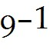|
Answer: 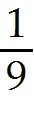
Type: SA
Objective: (1) Absolute Value

3) Simplify: |(-3 - 7)/ 2|
Answer: 5
Type: SA
Objective: (1) Absolute Value
4) Simplify: |3 - 8| - |8 - 3|
Answer: 0
Type: SA
Objective: (1) Absolute Value

5) Write without the absolute-value symbol: |1 - 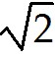|
Answer: - 1
Type: SA
Objective: (1) Absolute Value

6) Solve: |x| < 6
Answer: -6 < x < 6
Type: SA
Objective: (1) Absolute Value

7) Solve: 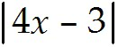 = 7
Answer: -1, 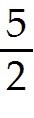
Type: SA
Objective: (1) Absolute Value

8) Solve: 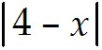 = 10
Answer: x = -6, 14
Type: SA
Objective: (1) Absolute Value

9) Solve: 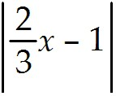 = 4
Answer: x = - 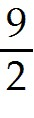, 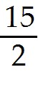
Type: SA
Objective: (1) Absolute Value

10) Solve: 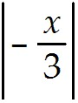 < 2
Answer: -6 < x < 6
Type: SA
Objective: (1) Absolute Value

11) Solve: 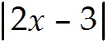 < -2
Answer: no solution
Type: SA
Objective: (1) Absolute Value

12) Solve: 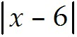 ≤ 6
Answer: 0 ≤ x ≤ 12
Type: SA
Objective: (1) Absolute Value
13) Solve: 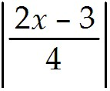 ≤ 1
Answer: - ≤ x ≤ 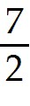
Type: SA
Objective: (1) Absolute Value

14) Solve: 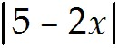 > 3
Answer: x < 1, x > 4
Type: SA
Objective: (1) Absolute Value

15) Solve: 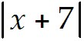 > -2
Answer: -∞ < x < ∞
Type: SA
Objective: (1) Absolute Value

16) Solve: 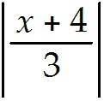 > 2
Answer: x < -10, x > 2
Type: SA
Objective: (1) Absolute Value

17) If x - 2 is less than 4 units from 0, then
A) 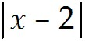 < 4.
B) > 4.
C) < 0.
D) > 0.
E) 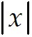 < 6.
Answer: A
Type: MC
Objective: (1) Absolute Value

18) If x > 10 or x < -10, then
A) < 10.
B) > 10.
C) 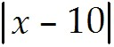 < 0.
D) < 10.
E) < -10.
Answer: B
Type: MC
Objective: (1) Absolute Value
19) The solution of 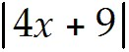 = 3 is
A) 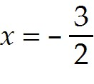 only
B) x = -3, - 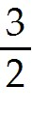 only
C) -3 ≤ x ≤ -
D) no solution
E) -∞ < x < ∞
Answer: B
Type: MC
Objective: (1) Absolute Value

20) The solution of 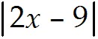 < 3 is
A) x > 3
B) x < 6
C) 3 < x < 6
D) x < 3, x > 6
E) 0 < x < 3
Answer: C
Type: MC
Objective: (1) Absolute Value

21) The solution of 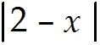 ≤ 5 is
A) -3 ≤ x ≤ 7
B) -7 ≤ x ≤ 3
C) x ≤ - 3, x ≥ 7
D) x ≤ -7, x ≥ 3
E) 0 ≤ x ≤ 3
Answer: A
Type: MC
Objective: (1) Absolute Value

22) The solution of ≤ -2 is
A) - ≤ x ≤
B) x ≤ - , x ≥
C) ≤ x ≤ 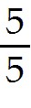
D) -∞ < x < ∞
E) no solution
Answer: E
Type: MC
Objective: (1) Absolute Value
23) The solution of 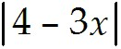 ≥ - 5 is
A) x ≥ 3
B) -3 ≤ x ≤ 3
C) x < - 3, x > 3
D) -∞ < x < ∞
E) no solution
Answer: D
Type: MC
Objective: (1) Absolute Value

24) The solution of 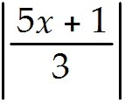 ≥ 2 is
A) x ≥ 1
B) - 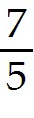 ≤ x ≤ 1
C) -1 ≤ x ≤
D) x ≤ - , x ≥ 1
E) x ≤ - 1, x ≥
Answer: D
Type: MC
Objective: (1) Absolute Value

25) Solve: -2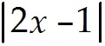 ≤ -.6
Answer: x ≤ - 1 or x ≥ 2
Type: SA
Objective: (1) Absolute Value

26) Solve: 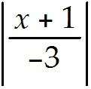 < 5
Answer: -16 < x < 14
Type: SA
Objective: (1) Absolute Value

27) If x lies in the interval (-2, 8), then
A) 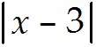 < 5
B) > 5
C) ≤ 5
D) ≥ 5
E) none of the above
Answer: A
Type: MC
Objective: (1) Absolute Value
28) If x ≤ -2 or x ≥ 8, then
A) < 5
B) > 5
C) ≤ 5
D) ≥ 5
E) none of the above
Answer: D
Type: MC
Objective: (1) Absolute Value

29) Solve: 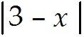 > 5
Answer: x < -2 or x > 8
Type: SA
Objective: (1) Absolute Value

30) Solve: x plus seven is a number 3 units from zero.
Answer: x = -4 or x = -10
Type: SA
Objective: (1) Absolute Value

31) Solve: Six plus three times x is a number 12 units from zero.
Answer: x = 2 or x = -6
Type: SA
Objective: (1) Absolute Value

32) Solve: Two times x plus nine is a number 13 units from zero.
Answer: x = 2 or x = -11
Type: SA
Objective: (1) Absolute Value

33) Solve: Three times x plus four is a number -4 units from zero.
Answer: A distance cannot be negative, so there is no solution.
Type: SA
Objective: (1) Absolute Value

34) The number x minus four is less than 6 units from zero. What are the possible values for x?
Answer: -2 < x < 10
Type: SA
Objective: (1) Absolute Value

35) Ten plus three times x is a number that is at most 11 units from 0. What are the possible values for x?
Answer: -7 ≤ x ≤
Type: SA
Objective: (1) Absolute Value

36) The number five minus two times x is less than 9 units from zero. What are the possible values for x?
Answer: -2 < x < 7
Type: SA
Objective: (1) Absolute Value
37) Six minus four times x is a number that is at most 14 units from zero. What are the possible values for x?
Answer: -2 ≤ x ≤ 5
Type: SA
Objective: (1) Absolute Value

38) The number x plus eight is at least 4 units from zero. What are the possible values for x?
Answer: x ≤ -12 or x ≥ -4
Type: SA
Objective: (1) Absolute Value

39) Three minus x is a number at least 6 units from zero. What are the possible values for x?
Answer: x ≤ -3 or x ≥ 9
Type: SA
Objective: (1) Absolute Value

40) Three times x plus five is a number that is more than 4 units from zero. What are the possible values for x?
Answer: x < -3 or x > -
Type: SA
Objective: (1) Absolute Value

41) Three minus three times x is a number that is more than 6 units from zero. What are the possible values for x?
Answer: x < -1 or x > 3
Type: SA
Objective: (1) Absolute Value

Express the problem using absolute value notation.

42) For safety reasons, the arrival time of commuter train A at a station must be at least 6 minutes different from the 6:00 p.m. arrival of train B.
Answer: 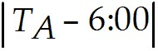 ≥ 6 min
Type: SA
Objective: (1) Absolute Value

43) The absolute value of the difference of two numbers is equal to the absolute value of the difference of the two numbers in reverse order.
Answer: 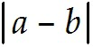 = 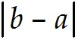
Type: SA
Objective: (1) Absolute Value

44) A number is always at least as large as the negative of its absolute value and at most as large as its absolute value.
Answer: -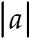 ≤ a ≤
Type: SA
Objective: (1) Absolute Value
45) The absolute value of the quotient of two numbers is equal to the quotient of the absolute values of the two numbers.
Answer: 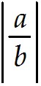 = 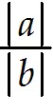
Type: SA
Objective: (1) Absolute Value

46) The absolute value of the product of two numbers is equal to the product of the absolute values of the numbers.
Answer: 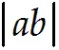 = 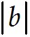
Type: SA
Objective: (1) Absolute Value

1.5 Summation Notation

Provide an appropriate response.

1) Give the bounds of summation and the index of summation for
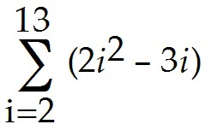
Answer: Index of Summation is i.
Bounds of Summation are 2 and 13.
Type: SA
Objective: (1) Summation Notation

2) Give the bounds of summation and the index of summation for
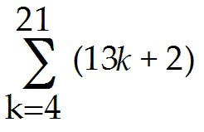
Answer: Index of Summation is k.
Bounds of Summation are 4 and 21.
Type: SA
Objective: (1) Summation Notation

3) Give the bounds of summation and the index of summation for
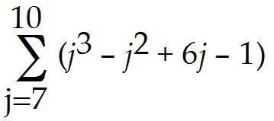
Answer: Index of Summation is k.
Bounds of Summation are 7 and 10.
Type: SA
Objective: (1) Summation Notation

4) Give the bounds of summation and the index of summation for
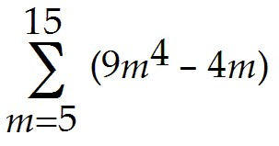
Answer: Index of Summation is m.
Bounds of Summation are 5 and 15.
Type: SA
Objective: (1) Summation Notation
5) Evaluate: 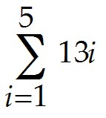
Answer: 195
Type: SA
Objective: (1) Summation Notation

6) Evaluate: 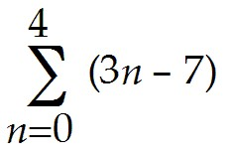
Answer: -5
Type: SA
Objective: (1) Summation Notation

7) Evaluate: 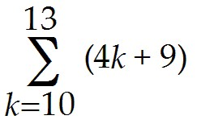
Answer: 220
Type: SA
Objective: (1) Summation Notation

8) Evaluate: 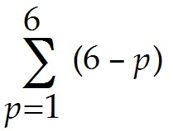
Answer: 15
Type: SA
Objective: (1) Summation Notation

9) Evaluate: 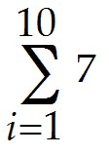
Answer: 70
Type: SA
Objective: (1) Summation Notation

10) Evaluate: 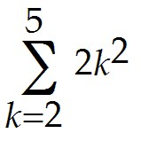
Answer: 108
Type: SA
Objective: (1) Summation Notation

11) Express the sum in summation notation.
4 + 6 + 8 + 10 + 12 + 14 + 16
Answer: 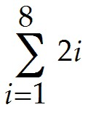
Type: SA
Objective: (1) Summation Notation
12) Express the sum in summation notation.
1 + 8 + 27 + 64 + 125 + 216
Answer: 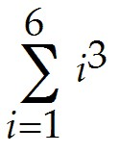
Type: SA
Objective: (1) Summation Notation

13) Express the sum in summation notation.
10 + 13 + 16 + 19 + 22 + 25 + 28 + 31
Answer: 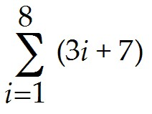
Type: SA
Objective: (1) Summation Notation

14) Express the sum in summation notation.
1 + + + + +
Answer: 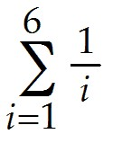
Type: SA
Objective: (1) Summation Notation

15) Express the sum in summation notation.
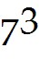 + 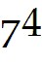 + 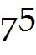 + 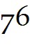 + 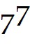 + 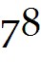 + 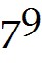
Answer: 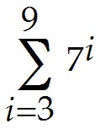
Type: SA
Objective: (1) Summation Notation

16) Express the sum in summation notation.
3 + + 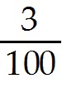 + 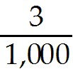 + 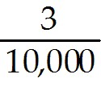 + 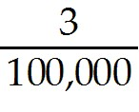 + 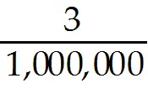
Answer: 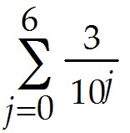
Type: SA
Objective: (1) Summation Notation

17) Express the sum in summation notation.
1 + 3 + 5 + 7 + 9 + 11 + 13 + 15 + 17 + ... + 37
Answer: 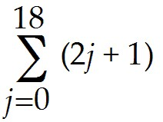
Type: SA
Objective: (1) Summation Notation
18) Express the sum in summation notation.
7 + 11 + 15 + 19 + 23 + 27 + ... + 67
Answer: 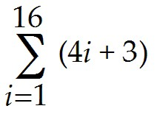
Type: SA
Objective: (1) Summation Notation

19) Evaluate: 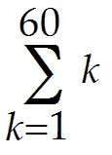
Answer: 1830
Type: SA
Objective: (1) Summation Notation

20) Evaluate: 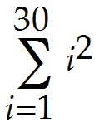
Answer: 9455
Type: SA
Objective: (1) Summation Notation

21) Evaluate: 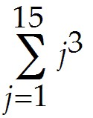
Answer: 14,400
Type: SA
Objective: (1) Summation Notation

22) Evaluate: 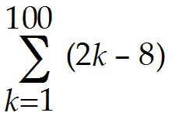
Answer: 9300
Type: SA
Objective: (1) Summation Notation

23) Evaluate: 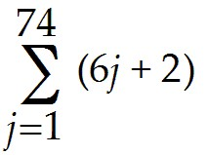
Answer: 16,798
Type: SA
Objective: (1) Summation Notation

24) Evaluate: 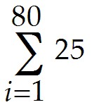
Answer: 2000
Type: SA
Objective: (1) Summation Notation
25) Evaluate: 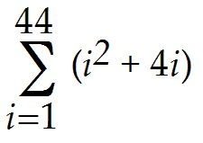
Answer: 33,330
Type: SA
Objective: (1) Summation Notation

26) Evaluate: 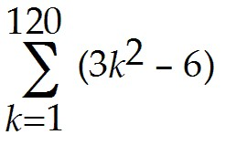
Answer: 1,748,680
Type: SA
Objective: (1) Summation Notation

27) Evaluate: 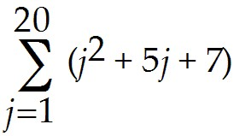
Answer: 4060
Type: SA
Objective: (1) Summation Notation

28) Evaluate: 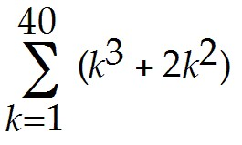
Answer: 716,680
Type: SA
Objective: (1) Summation Notation

29) Evaluate: 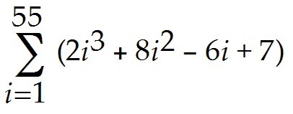
Answer: 5,190,185
Type: SA
Objective: (1) Summation Notation

30) Evaluate: 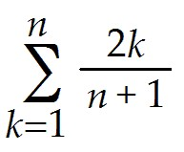
Answer: n
Type: SA
Objective: (1) Summation Notation

31) Evaluate: 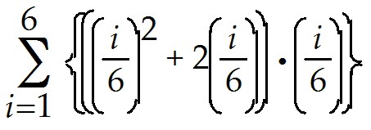
Answer: 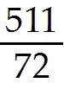
Type: SA
Objective: (1) Summation Notation
32) Evaluate: 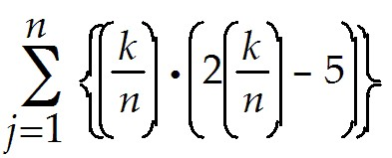
Answer: 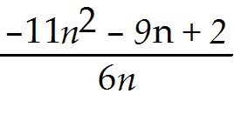
Type: SA
Objective: (1) Summation Notation

33) Evaluate: 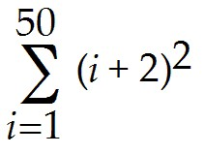
Answer: 48,225
Type: SA
Objective: (1) Summation Notation

34) Evaluate: 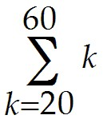
Answer: 1640
Type: SA
Objective: (1) Summation Notation

35) Evaluate: 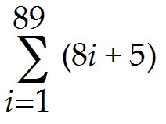
Answer: 31,995
Type: SA
Objective: (1) Summation Notation

36) Evaluate: 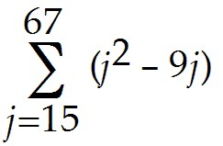
Answer: 81,938
Type: SA
Objective: (1) Summation Notation

37) Evaluate: 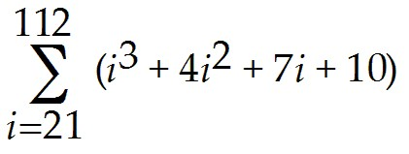
Answer: 41,930,150
Type: SA
Objective: (1) Summation Notation
1.6 Sequences

Write the indicated term of the given sequence.

1) a = 12, 24, 36, 48; 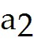
A) 24
B) 12
C) 2
D) 36
Answer: A
Type: BI
Objective: (1) Sequences

2) (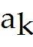) = 7(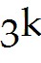);
A) 63
B) 189
C) 21
D) 567
Answer: A
Type: BI
Objective: (1) Sequences

Find a general term, (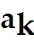), that fits the displayed terms of the given sequence.

3) 1, 5, 9, 13, 17
A) 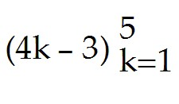
B) 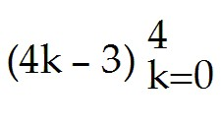
C) 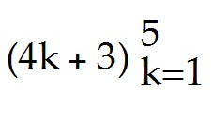
D) 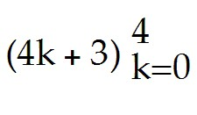
Answer: A
Type: BI
Objective: (1) Sequences

Determine whether the given sequences are equal to each other.

4) (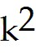 -9) and (k + 3)(k - 3)
A) equal
B) not equal
Answer: A
Type: BI
Objective: (1) Sequences
Determine the indicated term of the given recursively defined sequence.

5) 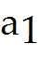 = 4, = 12, 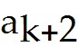 = 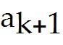 + 8; 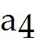
A) 28
B) 20
C) 36
D) 12
Answer: A
Type: BI
Objective: (1) Sequences

Write the first five terms of the arithmetic sequence with the given first term a and common difference d.

6) a = 4; d = 5
A) 4, 9, 14, 19, 24
B) 9, 14, 19, 24, 29
C) 0, 4, 9, 14, 19
D) 4, 8, 12, 16, 20
Answer: A
Type: BI
Objective: (1) Sequences

7) a = 21; d = -5
A) 21, 16, 11, 6, 1
B) 0, 21, 16, 11, 6
C) -21, -16, -11, -6, -1
D) 25, 19, 13, 7, 1
Answer: A
Type: BI
Objective: (1) Sequences

8) a = 12; d = -3
A) 12, 9, 6, 3, 0
B) 15, 12, 9, 6, 3
C) 9, 6, 3, 0, -3
D) 12, 9, 5, 3, 0
Answer: A
Type: BI
Objective: (1) Sequences

9) a = -16; d = 2
A) -16, -14, -12, -10, -8
B) -12, -10, -8, -6, -4
C) -8, -10, -12, -14, -16
D) -12, -14, -16, -18, -20
Answer: A
Type: BI
Objective: (1) Sequences
Write the first five terms of the geometric sequence with the given first term a and common ratio r.

10) a = 4; r = 5
A) 4, 20, 100, 500, 2500
B) 20, 100, 500, 2500, 12,500
C) 4, 9, 14, 19, 24
D) 5, 20, 80, 320, 1280
Answer: A
Type: BI
Objective: (1) Sequences

11) a = 6; r =
A) 6, 2, , 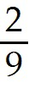, 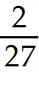
B) 6, 18, 54, 162, 486
C) 2, , , , 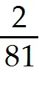
D) 6, 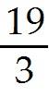, 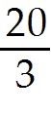, 7, 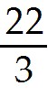
Answer: A
Type: BI
Objective: (1) Sequences

12) a = 6; r = -5
A) 6, -30, 150, -750, 3750
B) 6, 30, 150, -750, 3750
C) -5, -30, 150, -750, 3750
D) 6, 1, -4, -9, -14
Answer: A
Type: BI
Objective: (1) Sequences

13) a = -8; r = -4
A) -8, 32, -128, 512, -2048
B) -8, -32, -128, 512, -2048
C) -4, 32, -128, 512, -2048
D) -8, -12, -16, -20, -24
Answer: A
Type: BI
Objective: (1) Sequences
Find the indicated sum.

14) 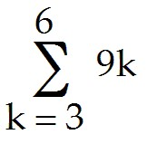
A) 162
B) 54
C) 81
D) 108
Answer: A
Type: BI
Objective: (1) Sequences

15) 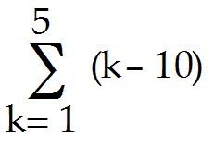
A) -35
B) -5
C) -14
D) -30
Answer: A
Type: BI
Objective: (1) Sequences

16) 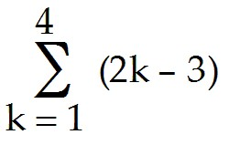
A) 8
B) 9
C) 5
D) 7
Answer: A
Type: BI
Objective: (1) Sequences

17) 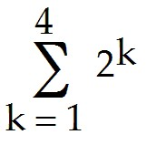
A) 30
B) 18
C) 14
D) 20
Answer: A
Type: BI
Objective: (1) Sequences
18) 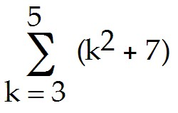
A) 71
B) 90
C) 45
D) 33
Answer: A
Type: BI
Objective: (1) Sequences

19) 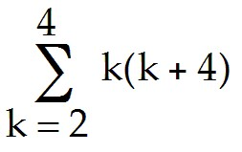
A) 65
B) 70
C) 44
D) 30
Answer: A
Type: BI
Objective: (1) Sequences

Find the infinite sum, if possible.

20) 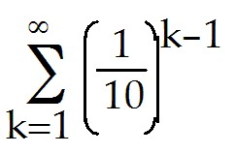
A) 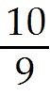
B)
C) -
D) not possible
Answer: A
Type: BI
Objective: (1) Sequences

Solve the problem.

21) To train for a race, Will begins by jogging 11 minutes one day per week. He increases his jogging time by 6 minutes each week. Write the general term of this arithmetic sequence, and find how many whole weeks it takes for him to reach a jogging time of one hour.
A) = 6k + 5; 10 weeks
B) = 6k + 11; 9 weeks
C) = 6k + 5; 9 weeks
D) = 6k + 11; 10 weeks
Answer: A
Type: BI
Objective: (1) Sequences
22) The population of a town is increasing by 400 inhabitants each year. If its population at the beginning of 1990 was 22,289, what was its population at the beginning of 1997?
A) 25,089 people
B) 155,939 people
C) 24,689 people
D) 311,878 people
Answer: A
Type: BI
Objective: (1) Sequences

23) A theater has 24 rows with 30 seats in the first row, 33 in the second row, 36 in the third row, and so forth. How many seats are in the theater?
A) 1548 seats
B) 1584 seats
C) 3096 seats
D) 3168 seats
Answer: A
Type: BI
Objective: (1) Sequences

24) Keyana takes a job with a starting salary of $31,000 for the first year with an annual increase of 4.5% beginning in the second year. What is Keyana's salary, to the nearest dollar, at the end of the seventh year?
A) $40,370
B) $41,089
C) $38,930
D) $42,850
Answer: A
Type: BI
Objective: (1) Sequences

25) Bob wants to save for a house downpayment by making, on a first day of every month, deposits of $ 500 into an account earning 0.5% monthly compound interest. If the first deposit is made on January 1, 2017, find the approximate value in Bob's account on December 31, 2022.
A) $ 2,625
B) $ 35,059
C) $ 30,143
D) $ 34,885
Answer: B
Type: MC
Objective: (1) Sequences

26) A fund is to be established to pay annual scholarships of $ 1,000, continuing forever. The first scholarship is payable in one years from now. If the annual rate of compound interest is 2.5%, find the value of the fund.
A) $ 25,000
B) $ 30,000
C) $ 35,000
D) $ 40,000
Answer: D
Type: MC
Objective: (1) Sequences

