Chapter 06
Process Selection and Facility Layout

True / False Questions
1. | Continuous processing is the best way to produce customized output.  True False

2. | As a general rule, continuous processing systems produce products for inventory rather than for customer order.  True False

3. | A job-shop processing system generally requires less-skilled workers than a continuous processing system.  True False

4. | Avoiding bottlenecks is the primary goal of product design.  True False

5. | In general, job-shop systems have a lower unit cost than continuous systems do because continuous systems use costly specialized equipment.  True False

6. | Continuous production has been a significant factor underpinning the U.S. standard of living over the last century.  True False

7. | Right-sized equipment tends to be larger than equipment used in traditional process layouts.  True False

8. | Intermittent processing can take the form of batch processing or a job shop.  True False

9. | The term "computer-aided manufacturing" refers primarily to the use of robotics in process control.  True False

10. | Flexible manufacturing systems bring the benefits of automation to continuous processes.  True False

11. | Repetitive processing systems usually produce goods specifically for customer orders rather than for inventory.  True False

12. | Morale problems can be a reason for redesign of a facility layout.  True False

13. | There are three basic process types: input, processing, and output.  True False

14. | A cafeteria line would be an example of a process-focused layout.  True False

15. | A possible disadvantage of a product layout is an inflexible system.  True False

16. | Product layouts involve high utilization of labor and equipment.  True False

17. | A manufacturing cell allows the production of a wide range of very different products.  True False

18. | Product layouts can more easily adapt to variations in product requirements than process layouts can.  True False

19. | Process layouts feature departments or other functional groupings of personnel or equipment.  True False

20. | Information technology refers to competitive data.  True False

21. | A process layout is more susceptible to shutdowns caused by equipment breakdowns than a product layout.  True False

22. | Accounting, purchasing, and inventory control are fairly routine with process layouts.  True False

23. | A disadvantage of a product layout can be high in-process inventory costs.  True False

24. | In cellular manufacturing, machines and equipment are grouped by type (e.g., all grinders are grouped into a cell).  True False

25. | Among the benefits claimed for cellular manufacturing are less material handling and reduced setup time.  True False

26. | Group technology is closely connected to cellular manufacturing.  True False

27. | The percentage of idle time in an assembly line is called cycle time.  True False

28. | Mismatches between operational capabilities and market demand can have a negative impact on an organization.  True False

29. | Service layouts must be visually pleasing as well as functional.  True False

30. | "Balance delay" is another name for the percentage of idle time in a product layout.  True False

31. | "Balance delay" is another name for the percentage of idle time in a process layout.  True False

32. | For a production line, daily capacity can be determined by dividing the daily operating time by the line's cycle time.  True False

33. | The minimum number of workstations for a production line is determined in part by the desired output rate.  True False

34. | The goal of line balancing is to assign tasks to workstations in such a way that the workstations have approximately equal time requirements.  True False

35. | An idle percentage of zero means a line is perfectly balanced.  True False

36. | None of the approaches to line balancing, manual or computerized, guarantees an optimal solution.  True False

37. | Heuristic approaches to line balancing are the only approach that will guarantee an optimal solution.  True False

38. | The main issue in the design of process layouts concerns the relative positioning of the departments involved.  True False

39. | An advantage of a U-shaped production line is that it facilitates teamwork and flexibility in work assignments.  True False

Multiple Choice Questions
40. | Key aspects of the process selection challenge include _________ and __________.  A. information technology; marketing strategy  B. process flexibility; marketing strategy  C. capital intensity; process flexibility  D. marketing strategy; operations strategy  E. capacity planning; marketing strategy

41. | When new products or services are being planned, process selection occurs as a matter of course. Process selection also comes into play as a result of:  (I) technological changes.  (II) competitive pressures.  (III) fundamental changes in demand patterns.  A. I only  B. II only  C. III only  D. I and II but not III  E. I, II, and III

42. | Process choice is _________ driven.  A. demand  B. operations  C. marketing  D. process  E. capacity

43. | The key questions in the process selection task are:  (I) How will the product/service be priced?  (II) How much variety will be imposed on the process?  (III) What is the target market for the product/service?  (IV) At what volume will the process need to operate?  A. I and III  B. II and IV  C. II and III  D. I and IV  E. III and IV

44. | Job shops tend to be __________ while continuous processes tend to be __________.  A. in services; in manufacturing  B. short-term and capital intensive; long-term and labor intensive  C. small scale and flexible; large-scale and inflexible  D. standardized; customized  E. low cost-per-unit; high cost-per-unit

45. | The estimation of costs is generally most difficult when the ___________ process has been chosen.  A. project  B. repetitive  C. continuous  D. batch  E. job shop

46. | In an environment in which demand is both substantial and stable, __________ technology tends to be the best choice.  A. batch production  B. fixed automation  C. project production  D. programmable automation  E. flexible automation

47. | Computer-integrated manufacturing integrates ______________ with manufacturing.  A. information from across the organization  B. demand forecasts  C. marketing strategy  D. human resources  E. inventory levels

48. | Which of the following is not a process commonly considered in making products or delivering services?  A. continuous  B. batch  C. repetitive  D. job shop  E. subcontracting

49. | The type of processing system which is used for highly standardized products is:  A. continuous.  B. intermittent.  C. project.  D. batch.  E. unit.

50. | Cellular layout is a term associated with:  A. wireless telecommunication.  B. part families.  C. functional (or process) layouts.  D. assembly lines.  E. job shops.

51. | The substitution of machinery that has sensing and control devices for human labor is best described by the term:  A. automation.  B. feedback control.  C. computer-aided manufacturing.  D. computer-integrated manufacturing.  E. flexible manufacturing system.

52. | Computer-aided manufacturing refers to the use of computers in:  A. product design.  B. decision making.  C. data analysis.  D. quality control.  E. process control.

53. | A group of machines including supervisory computer control, automatic material handling, and possibly robots is called:  A. computer-aided design.  B. a manufacturing cell.  C. computer-aided manufacturing.  D. computer-integrated manufacturing.  E. a flexible manufacturing system.

54. | In which type of operation are you likely to see, at most, only minor variations in the product or service being produced using the same process and the same equipment?  A. a project  B. a job shop  C. repetitive production  D. batch processing  E. intermittent production

55. | The process of assigning tasks to workstations in such a way that the workstations have approximately equal time requirements is called:  A. fair employment practices.  B. idle time analysis.  C. line balancing.  D. cycle time optimization.  E. capacity cycling.

56. | An operations strategy for process selection should recognize that:  A. process selection seldom requires technical expertise.  B. engineering "white elephants" are uncommon.  C. there is little need to manage technology.  D. flexibility is not always the best choice.  E. most technical skills can be contracted out to consultants.

57. | Layout planning is required because of:  (I) efficient operations.  (II) accidents or safety hazards.  (III) new products or services.  (IV) morale problems.  A. I and II  B. II and IV  C. I and III  D. II, III, and IV  E. I, II, III, and IV

58. | The advantages of automation include:  (I) reduced output variability.  (II) reduced variable costs.  (III) machines don't strike or file grievances.  (IV) machines are always less expensive than human labor.  A. I and IV  B. II and III  C. I, II, and III  D. I and III  E. II and IV

59. | As compared to rigid automation, the benefits of flexible manufacturing systems include:  A. reduced labor requirements.  B. higher efficiency.  C. larger batch sizes.  D. significantly lower fixed costs.  E. significantly lower variable costs.

60. | Which type of processing system tends to produce the most product variety?  A. assembly  B. job shop  C. batch  D. continuous  E. project

61. | In which type of processing system would gasoline be produced from crude oil?  A. job shop  B. batch  C. assembly  D. continuous  E. project

62. | Which of the following is not a characteristic of layout decisions in system design?  A. substantial investment of both money and effort  B. long-term commitment  C. significant impact on short-term efficiency  D. usually well received by operative personnel  E. can affect supplier or customer processes

63. | An example of automated services is:  A. online banking.  B. build your own pizza.  C. haircuts.  D. massage parlors.  E. financial advising.

64. | Which one of the following is not common to product layouts?  A. a high rate of output  B. specialization of labor  C. low unit costs  D. ability to adjust to changes in demand  E. special-purpose technology

65. | Which one of the following is not considered an important factor in service layout design?  A. cost minimization and product flow  B. frequency of orders  C. customer attitude and image  D. intensity of contact with the customer  E. customer preferences with regard to variety

66. | The type of layout which features departments or other functional groupings in which similar activities are performed is:  A. process.  B. product.  C. fixed-position.  D. mass.  E. unit.

67. | Which of the following is not true about process layouts when they are compared to product layouts?  A. higher in-process inventories  B. lower span of supervision  C. lower rates of output  D. more involved cost accounting  E. lower unit costs

68. | The type of layout in which workers, materials, and equipment are moved to the product as needed is:  A. process.  B. product.  C. fixed-position.  D. batch.  E. mass.

69. | The grouping of equipment by the operations needed to perform similar work for part families is:  A. product layout.  B. cellular manufacturing layout.  C. functional layout.  D. fixed-position layout.  E. process layout.

70. | Which term is most closely associated with cellular manufacturing?  A. part families  B. assembly line  C. robotics  D. CAD  E. CAM

71. | Laser technology used in surgical procedures is an example of technological advances in:  A. product.  B. facility layout.  C. process.  D. information.  E. reverse engineering.

72. | Product profiling links key product or service requirements to:  A. market conditions.  B. order sizes.  C. pricing strategies.  D. schedule changes.  E. process capabilities.

73. | Layout design has many objectives, one of which is:  A. reduce bottlenecks.  B. move materials and workers simultaneously.  C. use workers and space efficiently.  D. hold material handling costs to 27 percent or less.  E. install computer terminals every 500 feet.

74. | Which phrase most closely describes flexible manufacturing systems?  A. a variation of CAD  B. a more fully automated version of cellular manufacturing  C. manufacturing resource planning  D. a process layout with a manufacturing overlay  E. an approach that allows workers to begin work at a time of their choosing

75. | A service organization (for example, a hospital) is likely to use a(n) ________ layout because of variability in customer processing requirements.  A. project  B. process  C. flow  D. assembly  E. nonrepetitive

76. | In a product layout, the task of deciding how to assign work to specific stations is referred to as:  A. process balancing.  B. task allocation.  C. line balancing.  D. work allocation.  E. station balancing.

77. | The minimum possible cycle time in a product layout is determined by the:  A. longest task time.  B. shortest task time.  C. average task time.  D. total task time.  E. per-unit setup time.

78. | A production line is to be designed for a job with three tasks. The task times are .4 minutes, 1.2 minutes, and .5 minutes. The maximum cycle time in minutes is:  A. .3.  B. .7.  C. 1.4.  D. 2.1.  E. .8.

79. | A production line is to be designed for a job with three tasks. The task times are .3 minutes, 1.4 minutes, and .7 minutes. The minimum cycle time in minutes is:  A. .3.  B. .7.  C. 1.4.  D. 2.4.  E. .8.

80. | Daily capacity of a product layout is determined by:  A. cycle time divided by operating time.  B. operating time divided by cycle time.  C. operating time divided by total task time.  D. total task time divided by cycle time.  E. cycle time divided by total task time.

81. | The maximum allowable cycle time is computed as:  A. daily operating time divided by the desired output.  B. desired output divided by the daily operating time.  C. daily operating time divided by the product of the desired output and the sum of job times.  D. the product of desired output and the sum of job times divided by daily operating time.  E. 1.00 minus station time.

82. | If a line is balanced with 80 percent efficiency, the "balance delay" will be:  A. 20 percent.  B. 80 percent.  C. 100 percent.  D. unknown, since balance delay is not related to efficiency.  E. depends on the next operation.

83. | The main issue in the design of process layouts for service operations concerns the relative positioning of:  A. workstations.  B. processing components.  C. departments.  D. entrances, loading docks, etc.  E. manufacturing cells.

84. | Which of the following is not an information requirement for the design of a process layout?  A. a list of departments or work centers  B. a projection of work flows between the work centers  C. the distance between locations  D. the cost per unit of distance to move loads  E. a list of product cycle times for every product manufactured

85. | Which of the following is not an approach that companies use to achieve a smooth flow of production?  A. line balancing heuristics  B. parallel workstations  C. dynamic line balancing (cross-training workers)  D. mixed model line  E. Companies use all of these.

86. | A common goal in designing process layouts is:  A. minimizing the number of workers.  B. minimizing idle time.  C. minimizing transportation costs.  D. maximizing workstation productive time.  E. maximizing transportation distances.

87. | In the use of closeness ratings for process layouts, the code U means the closeness between two departments is:  A. (U)nknown.  B. (U)nusually important.  C. of (U)sual importance.  D. (U)nimportant.  E. (U)ndesirable.

88. | Which closeness rating reflects the undesirability of having two departments located near each other?  A. A  B. E  C. I  D. U  E. X

89. | Which closeness rating reflects the highest importance for two departments being close to each other?  A. A  B. E  C. I  D. U  E. X

90. | Which closeness rating reflects indifference on the nearness or lack of nearness of two departments?  A. A  B. E  C. I  D. U  E. X

91. | Heuristic rules are used primarily in which of these types of layouts?  (I) Product  (II) Process  (III) Fixed-position  A. I  B. II  C. I and III  D. I and II  E. II and III

92. | Heuristic rules are usually applied when:  A. an optimum is necessary.  B. a computer program is unavailable.  C. a problem has a small number of alternatives.  D. a problem has a large number of alternatives.  E. other approaches have failed.

93. | An advantage of a U-shaped production line is that:  A. it is less compact.  B. communication is reduced among employees.  C. workers are specialists.  D. work assignments are more rigid.  E. it is more efficient than a traditional product layout.

94. | Which of these items would be most likely to be made with a fixed-position layout?  A. a Boeing 777 jet aircraft  B. applesauce  C. a computer chip  D. toothpaste  E. all of these

95. | A product-focused, single-piece flow, pull production system would be called a:  A. cellular layout.  B. job shop.  C. assembly line.  D. nonrepetitive process.  E. continuous flow.

96. | Which one of these is a tool used to tell a machine the details of the operations to be performed?  A. CNC  B. CIM  C. CAD  D. CAM  E. automation

97. | Which of the following is not a primary concern for process selection?  A. variety in products/services  B. flexibility of equipment  C. volume of output  D. pricing strategy  E. changeover costs

98. | A company is designing a product layout for a new product. It plans to use this production line eight hours a day in order to meet projected demand of 480 units per day. The tasks necessary to produce this product are:  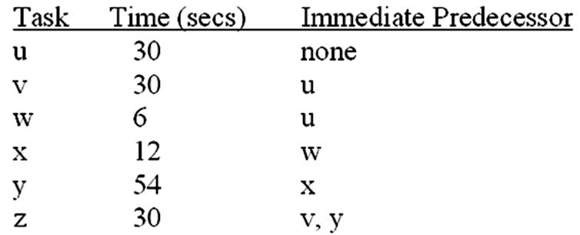  Without regard to demand, what is the minimum possible cycle time (in seconds) for this situation?  A. 162  B. 72  C. 54  D. 12  E. 60

99. | A company is designing a product layout for a new product. It plans to use this production line eight hours a day in order to meet projected demand of 480 units per day. The tasks necessary to produce this product are:  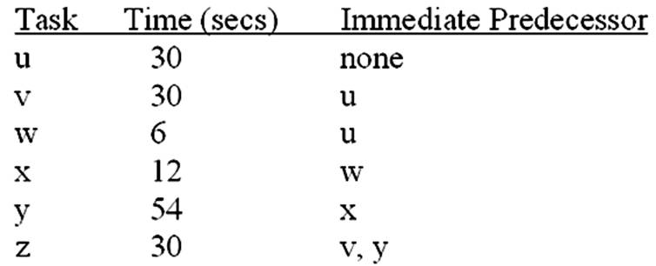  If the company wants the output rate to be equal to demand, what is the desired cycle time (in seconds)?  A. 162  B. 72  C. 54  D. 12  E. 60

100. | A company is designing a product layout for a new product. It plans to use this production line eight hours a day in order to meet projected demand of 480 units per day. The tasks necessary to produce this product are:  If the company wants the output rate to be equal to demand, what is the minimum number of workstations needed?  A. 3  B. 4  C. 5  D. 6  E. 7

101. | A company is designing a product layout for a new product. It plans to use this production line eight hours a day in order to meet projected demand of 480 units per day. The tasks necessary to produce this product are:  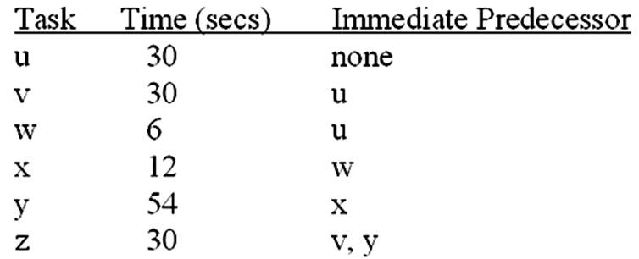  If the company wants the output rate to be equal to demand, what would be the efficiency of this line with the minimum number of workstations?  A. 100 percent  B. 92.5 percent  C. 75 percent  D. 87.5 percent  E. 90 percent

102. | A company is designing a product layout for a new product. It plans to use this production line eight hours a day in order to meet projected demand of 480 units per day. The tasks necessary to produce this product are:  If the company wants the output rate to be equal to demand, what is the last task performed at the second workstation in the balance which uses the minimum number of workstations?  A. u  B. v  C. w  D. x  E. y

103. | QRS Corp. is designing a product layout for a new product. They plan to use this production line 10 hours a day in order to meet forecasted demand of 900 units per day. The following table describes the tasks necessary to produce this product:  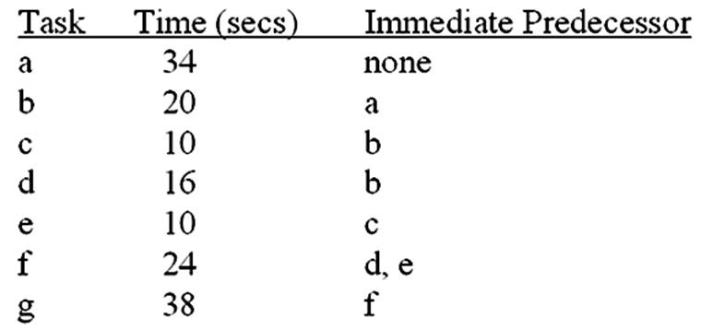  Without considering forecasted demand, what is the minimum possible cycle time for this production line?  A. 10 seconds  B. 20 seconds  C. 34 seconds  D. 38 seconds  E. 152 seconds

104. | QRS Corp. is designing a product layout for a new product. They plan to use this production line 10 hours a day in order to meet forecasted demand of 900 units per day. The following table describes the tasks necessary to produce this product:  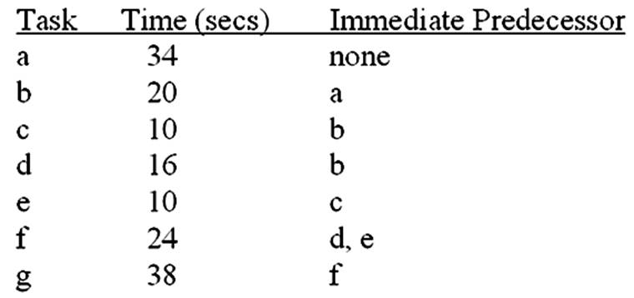  For output to equal forecasted demand, what should be the actual cycle time for this production?  A. 32 seconds  B. 38 seconds  C. 40 seconds  D. 76 seconds  E. 152 seconds

105. | QRS Corp. is designing a product layout for a new product. They plan to use this production line 10 hours a day in order to meet forecasted demand of 900 units per day. The following table describes the tasks necessary to produce this product:  For output to equal forecasted demand, what is the minimum number of workstations needed?  A. 1  B. 3  C. 3.75  D. 4  E. 5

106. | QRS Corp. is designing a product layout for a new product. They plan to use this production line 10 hours a day in order to meet forecasted demand of 900 units per day. The following table describes the tasks necessary to produce this product:  For output to equal forecasted demand, what will be the efficiency of the production line that uses the least number of workstations?  A. 81 percent  B. 90 percent  C. 95 percent  D. 85 percent  E. 100 percent

107. | QRS Corp. is designing a product layout for a new product. They plan to use this production line 10 hours a day in order to meet forecasted demand of 900 units per day. The following table describes the tasks necessary to produce this product:  For output to equal forecasted demand, what will be the second task performed at the second workstation of the production line that uses the fewest number of stations?  A. a  B. b  C. c  D. d  E. e

108. | The maker of the world-famous Chocolate Chip Cookies needs to design a product layout for a new product, Mint Chocolate Chip. The company plans to use this new production line eight hours a day in order to meet projected demand of 1,440 cases per day. The following table describes the tasks involved in the production of a Mint Chocolate Chip Cookie.  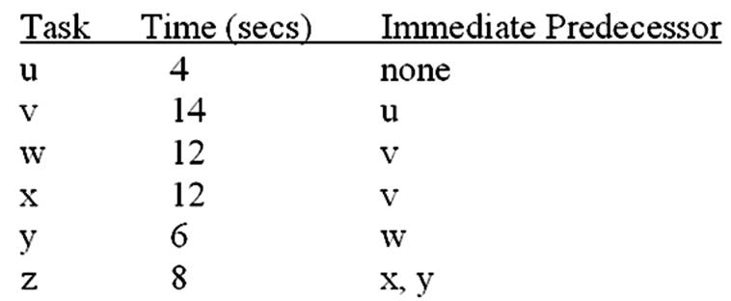  Without considering projected demands, what is the minimum possible cycle time for this production line?  A. 54 seconds  B. 14 seconds  C. 12 seconds  D. 10 seconds  E. 4 seconds

109. | The maker of the world-famous Chocolate Chip Cookies needs to design a product layout for a new product, Mint Chocolate Chip. The company plans to use this new production line eight hours a day in order to meet projected demand of 1,440 cases per day. The following table describes the tasks involved in the production of a Mint Chocolate Chip Cookie.  For output to equal projected demand, what should be the actual cycle time for this production line?  A. 54 seconds  B. 27 seconds  C. 20 seconds  D. 18 seconds  E. 14 seconds

110. | The maker of the world-famous Chocolate Chip Cookies needs to design a product layout for a new product, Mint Chocolate Chip. The company plans to use this new production line eight hours a day in order to meet projected demand of 1,440 cases per day. The following table describes the tasks involved in the production of a Mint Chocolate Chip Cookie.  For output to equal projected demand, what is the minimum number of workstations needed?  A. 6  B. 4.5  C. 3  D. 2.7  E. 2

111. | The maker of the world-famous Chocolate Chip Cookies needs to design a product layout for a new product, Mint Chocolate Chip. The company plans to use this new production line eight hours a day in order to meet projected demand of 1,440 cases per day. The following table describes the tasks involved in the production of a Mint Chocolate Chip Cookie.  For output to equal projected demand, what will be the efficiency of the production line that uses the minimum number of workstations?  A. 93.33 percent  B. 95 percent  C. 97 percent  D. 99 percent  E. 100 percent

112. | The maker of the world-famous Chocolate Chip Cookies needs to design a product layout for a new product, Mint Chocolate Chip. The company plans to use this new production line eight hours a day in order to meet projected demand of 1,440 cases per day. The following table describes the tasks involved in the production of a Mint Chocolate Chip Cookie.  For output to equal projected demand, what will be the first task performed at the third workstation of the production line which uses the minimum number of stations?  A. u  B. v  C. w  D. x  E. y

113. | A company needs to rebalance a product layout for producing new plastic license plates. They plan to use the assembly line six hours in order to meet projected demand of 2,160 license plates each day. The following table describes the tasks involved in the production of this product:  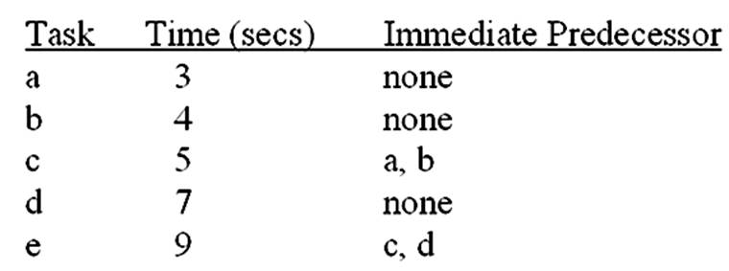  Without regard to projected demand, what is the minimum possible cycle time for this assembly line?  A. 0 seconds  B. 3 seconds  C. 9 seconds  D. 10 seconds  E. 28 seconds

114. | A company needs to rebalance a product layout for producing new plastic license plates. They plan to use the assembly line six hours in order to meet projected demand of 2,160 license plates each day. The following table describes the tasks involved in the production of this product:  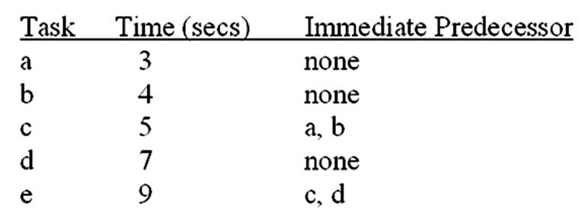  For output to equal projected demand, what should be the actual cycle time for this assembly line?  A. 0 seconds  B. 3 seconds  C. 9 seconds  D. 10 seconds  E. 28 seconds

115. | A company needs to rebalance a product layout for producing new plastic license plates. They plan to use the assembly line six hours in order to meet projected demand of 2,160 license plates each day. The following table describes the tasks involved in the production of this product:  For output to equal projected demand, what is the minimum number of workstations needed?  A. 2  B. 2.8  C. 3  D. 4  E. 5

116. | A company needs to rebalance a product layout for producing new plastic license plates. They plan to use the assembly line six hours in order to meet projected demand of 2,160 license plates each day. The following table describes the tasks involved in the production of this product:  For output to equal projected demand, what will be the efficiency of the assembly line that uses the minimum number of workstations?  A. 0.0 percent  B. 6.7 percent  C. 70.0 percent  D. 93.3 percent  E. 100 percent

117. | A company needs to rebalance a product layout for producing new plastic license plates. They plan to use the assembly line six hours in order to meet projected demand of 2,160 license plates each day. The following table describes the tasks involved in the production of this product:  For output to equal projected demand, what will be the idle time at the second workstation of the assembly line that uses the minimum number of workstations?  A. 0 seconds  B. 1 second  C. 2 seconds  D. 3 seconds  E. 5 seconds

118. | A company needs to locate three departments (X, Y, and Z) in the three areas (I, II, and III) of a new facility. They want to minimize interdepartmental transportation costs, which are expected to be $.50 per load per meter moved. An analyst has prepared the following distances and flow matrices:  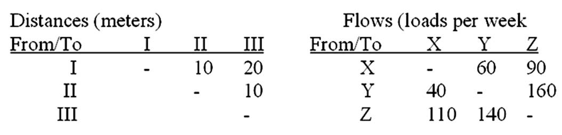  What is the distance (in meters) from area III to area I in this new facility?  A. 0  B. 10  C. 20  D. 30  E. 40

119. | A company needs to locate three departments (X, Y, and Z) in the three areas (I, II, and III) of a new facility. They want to minimize interdepartmental transportation costs, which are expected to be $.50 per load per meter moved. An analyst has prepared the following distances and flow matrices:  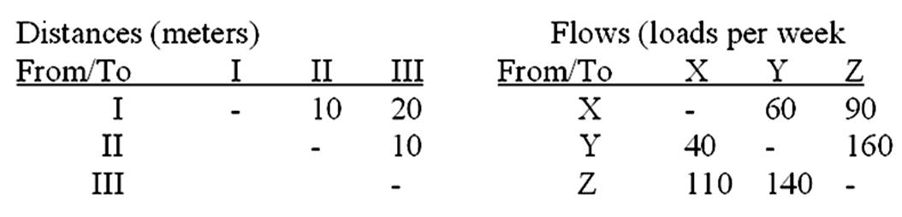  What is the total flow (loads per week) between department Y and department Z?  A. 140  B. 160  C. 200  D. 250  E. 300

120. | A company needs to locate three departments (X, Y, and Z) in the three areas (I, II, and III) of a new facility. They want to minimize interdepartmental transportation costs, which are expected to be $.50 per load per meter moved. An analyst has prepared the following distances and flow matrices:  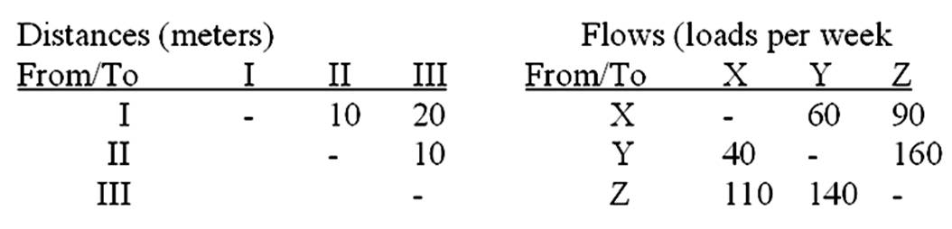  If departments X, Y, and Z were to be located in areas I, II, and III, respectively, what would be the total distance (in meters) loads would be moved each week?  A. 4,000  B. 4,500  C. 7,000  D. 8,000  E. 9,000

121. | A company needs to locate three departments (X, Y, and Z) in the three areas (I, II, and III) of a new facility. They want to minimize interdepartmental transportation costs, which are expected to be $.50 per load per meter moved. An analyst has prepared the following distances and flow matrices:  What are total weekly costs for the least costly process layout?  A. $2,800  B. $3,150  C. $3,500  D. $4,000  E. $4,500

122. | A company needs to locate three departments (X, Y, and Z) in the three areas (I, II, and III) of a new facility. They want to minimize interdepartmental transportation costs, which are expected to be $.50 per load per meter moved. An analyst has prepared the following distances and flow matrices:  How many least costly process layouts are there?  A. 1  B. 2  C. 3  D. 4  E. 5

123. | A company needs to locate three departments (X, Y, and Z) in the three areas (I, II, and III) of a new facility. They want to minimize interdepartmental transportation costs, which are expected to be $.50 per load meter moved. An analyst has prepared the following flow and distance matrices:  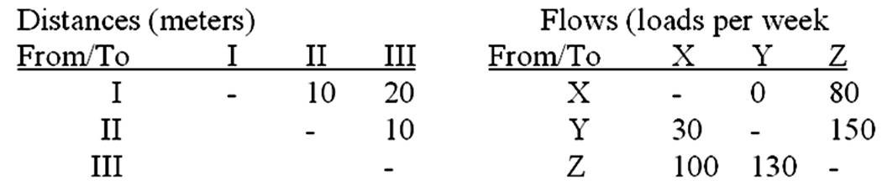  What is the distance (in meters) from area III to area I of this new facility?  A. 0  B. 10  C. 20  D. 30  E. 40

124. | A company needs to locate three departments (X, Y, and Z) in the three areas (I, II, and III) of a new facility. They want to minimize interdepartmental transportation costs, which are expected to be $.50 per load meter moved. An analyst has prepared the following flow and distance matrices:  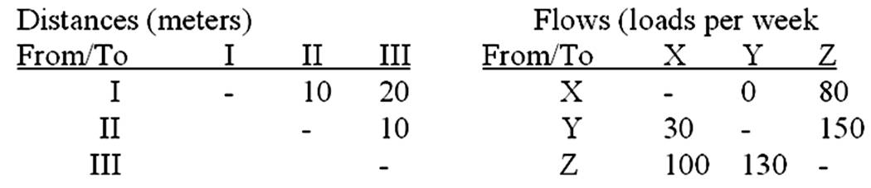  What is the total flow (loads per week) between department Y and department Z?  A. 130  B. 150  C. 180  D. 230  E. 280

125. | A company needs to locate three departments (X, Y, and Z) in the three areas (I, II, and III) of a new facility. They want to minimize interdepartmental transportation costs, which are expected to be $.50 per load meter moved. An analyst has prepared the following flow and distance matrices:  If the company were to locate departments X, Y, and Z in areas 1, 2, and 3, respectively, what would be the total distance (in meters) loads would be moved each week?  A. 3,100  B. 3,600  C. 6,200  D. 6,700  E. 8,200

126. | A company needs to locate three departments (X, Y, and Z) in the three areas (I, II, and III) of a new facility. They want to minimize interdepartmental transportation costs, which are expected to be $.50 per load meter moved. An analyst has prepared the following flow and distance matrices:  What is the layout that will minimize the total distance loads will be moved each week?  A. X in 1; Y in 2; Z in 3  B. X in 1; Z in 2; Y in 3  C. Y in 1; X in 2; Z in 3  D. Z in 1; X in 2; Y in 3  E. Z in 1; Y in 2; X in 3

127. | A company needs to locate three departments (X, Y, and Z) in the three areas (I, II, and III) of a new facility. They want to minimize interdepartmental transportation costs, which are expected to be $.50 per load meter moved. An analyst has prepared the following flow and distance matrices:  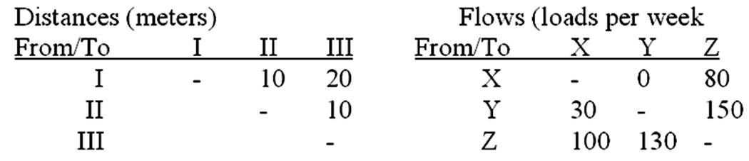  What are total weekly costs for an optimum layout?  A. $2,600  B. $3,600  C. $6,200  D. $7,200  E. $8,200

128. | Which of the following process types would be most likely to be used in the introductory phase of a product's life cycle?  A. continuous  B. intermittent  C. project  D. batch  E. job shop

129. | Which of the following process types would be most likely to be used in the maturity phase of a product's life cycle?  A. repetitive  B. intermittent  C. project  D. batch  E. job shop

130. | What is it about job shops that make them appropriate for products in the introductory phase of their life cycle?  A. efficiency  B. technology  C. flexibility  D. high volume capacity  E. rigidity

131. | What is it about repetitive processes that make them appropriate for products in the maturity phase of their life cycle?  A. efficiency  B. general-purpose technology  C. possible variety  D. low risk  E. flexibility

132. | Although they do not guarantee optimal solutions, ______________ are useful in finding reasonable solutions when the number of possible options is overwhelming.  A. cellular layouts  B. heuristics  C. logistics  D. CAM  E. CAD

Essay Questions
133. | Management wants to design an assembly line that will turn out 800 videotapes per day. There will be eight working hours in each day. The industrial engineering staff has assembled the information below:  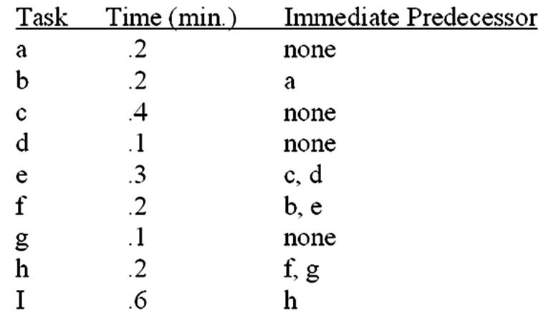  A) Determine the maximum and minimum cycle times.  B) Determine the optimum cycle time.  C) What is the minimum number of stations needed?  D) Draw the precedence diagram.  E) Assign tasks to stations in order of most following tasks first.

134. | Given the information below, assign departments to locations in a 3 x 3 grid, with department F in the lower right-hand corner.  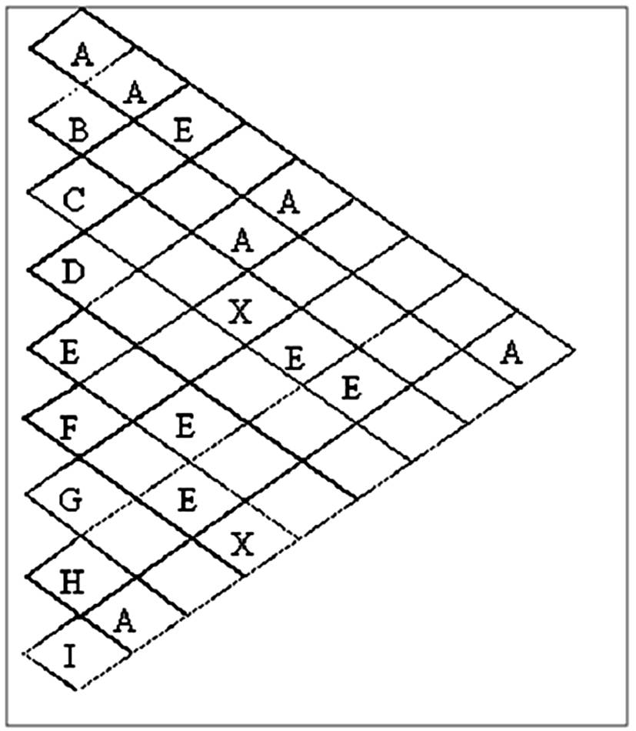

135. | Given the information below, assign the departments A through I to locations in a 3 x 3 grid, with department E fixed in the lower right-hand corner.  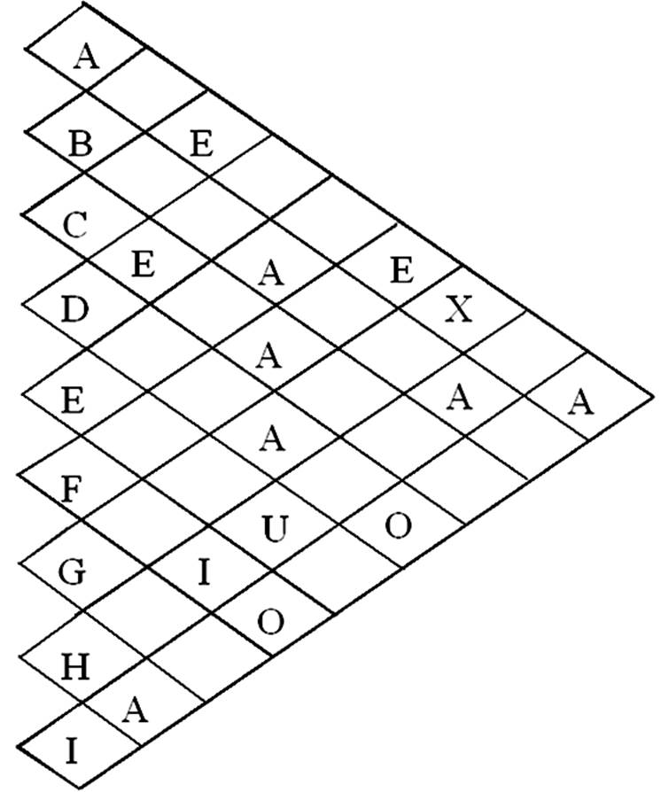

136. | Determine the minimum number of workstations needed for this situation:  Operating time is 450 minutes per day.  Desired output is 80 units per day.  The sum of task times is 56 minutes.

137. | Given the following data:  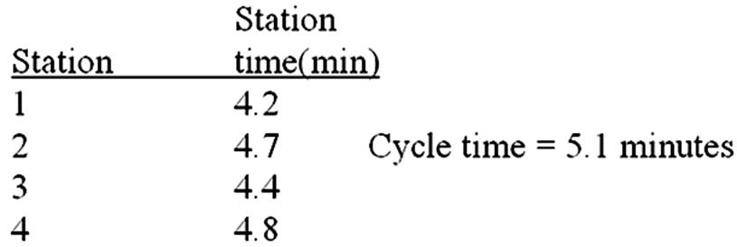  Determine the percentage idle time.

138. | Given the following process layout data for locating six departments in the six areas shown:  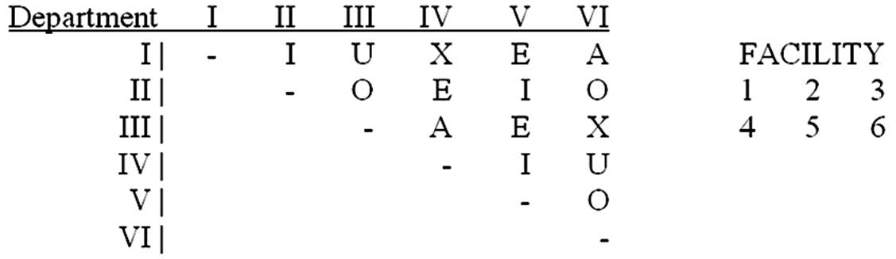  What process layout(s) satisfy(ies) these closeness ratings?

139. | Given the following line balance data:  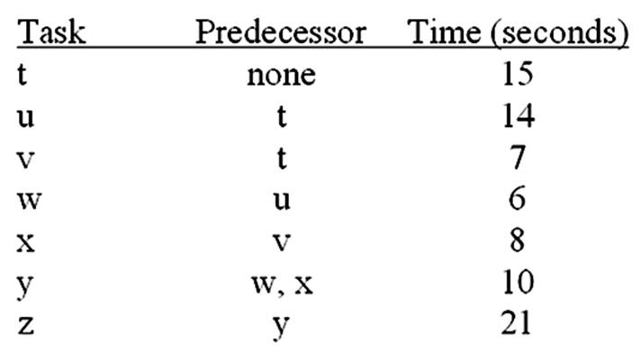  What is the minimum possible cycle time?

140. | Given the following line balance data:  What is the maximum possible cycle time?

141. | Given the following line balance data:  What is the appropriate cycle time for eight hours of operating time per day and a desired output rate of 960 units per day?

142. | Given the following line balance data:  For eight hours of operating time per day and a desired output rate of 960 units per day, what is the minimum number of stations needed to achieve the appropriate cycle time?

143. | Given the following line balance data:  For eight hours of operating time per day and a desired output rate of 960 units per day, what balance (if any) will yield the minimum number of stations?

144. | Given the following line balance data:  For eight hours of operating time per day and a desired output rate of 960 units per day, what is the percentage of idle time for the balance which uses the minimum number of stations?

145. | Given the following line balance data:  For eight hours of operating time per day and a desired output rate of 960 units per day, what is the efficiency for the balance which uses the minimum number of stations?

146. | Given the following process layout data for locating four departments (A, B, C, and D) in four areas (1, 2, 3, and 4):  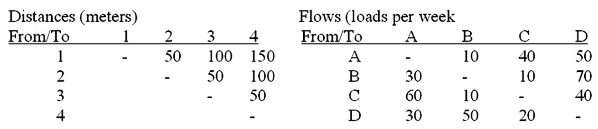  What is the distance from area 3 to area 1?

147. | Given the following process layout data for locating four departments (A, B, C, and D) in four areas (1, 2, 3, and 4):  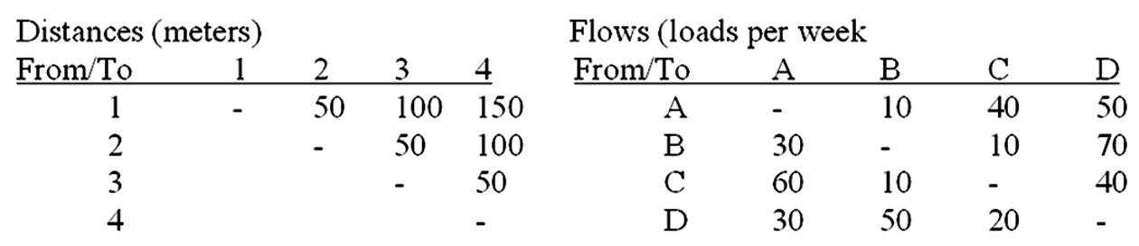  What is the total flow between departments B and D?

148. | Given the following process layout data for locating four departments (A, B, C, and D) in four areas (1, 2, 3, and 4):  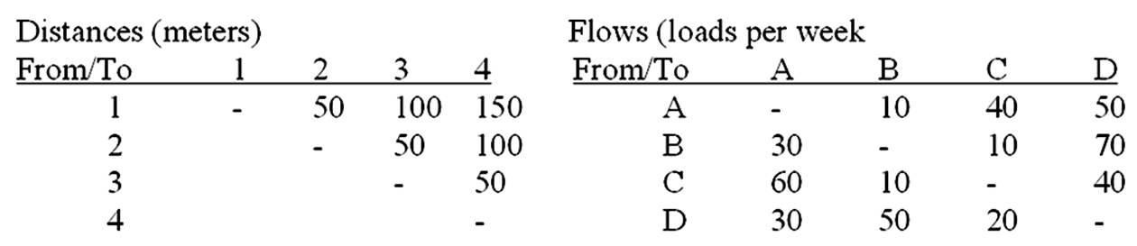  If departments A through D were to be located in areas 1 through 4, respectively, what would be the total distance loads would be moved each month?

149. | Given the following process layout data for locating four departments (A, B, C, and D) in four areas (1, 2, 3, and 4):  If department C must be located in area 1, what layout will minimize the total distance loads will be moved each month?

150. | Given the following process layout data for locating four departments (A, B, C, and D) in four areas (1, 2, 3, and 4):  If transportation costs are $.25 per load per foot moved, what are total monthly costs for an optimum layout?

Chapter 06 Process Selection and Facility Layout Answer Key
True / False Questions
1. | Continuous processing is the best way to produce customized output.  FALSE  Continuous processing is best for standardized output.

AACSB: Reflective Thinking
Accessibility: Keyboard Navigation
Blooms: Understand
Learning Objective: 06-01 Explain the strategic importance of process selection and the influence it has on the organization and its supply chain.
Level of Difficulty: 1 Easy
Topic: Process Selection

2. | As a general rule, continuous processing systems produce products for inventory rather than for customer order.  TRUE  Continuous processing systems tend to be used in make-to-stock scenarios.

AACSB: Reflective Thinking
Accessibility: Keyboard Navigation
Blooms: Remember
Learning Objective: 06-03 Compare the four basic processing types.
Level of Difficulty: 2 Medium
Topic: Process Selection

3. | A job-shop processing system generally requires less-skilled workers than a continuous processing system.  FALSE  Job shops require greater skill on the part of their workers.

AACSB: Reflective Thinking
Accessibility: Keyboard Navigation
Blooms: Understand
Learning Objective: 06-03 Compare the four basic processing types.
Level of Difficulty: 2 Medium
Topic: Process Selection

4. | Avoiding bottlenecks is the primary goal of product design.  FALSE  Avoiding bottlenecks is a primary consideration in facilities layout.

AACSB: Reflective Thinking
Accessibility: Keyboard Navigation
Blooms: Understand
Learning Objective: 06-05 List some reasons for redesign of layouts.
Level of Difficulty: 1 Easy
Topic: Process Strategy

5. | In general, job-shop systems have a lower unit cost than continuous systems do because continuous systems use costly specialized equipment.  FALSE  Specialized equipment can lead to lower unit cost.

AACSB: Reflective Thinking
Accessibility: Keyboard Navigation
Blooms: Understand
Learning Objective: 06-03 Compare the four basic processing types.
Level of Difficulty: 3 Hard
Topic: Process Selection

6. | Continuous production has been a significant factor underpinning the U.S. standard of living over the last century.  TRUE  Continuous production has led to substantial productivity gains.

AACSB: Reflective Thinking
Accessibility: Keyboard Navigation
Blooms: Remember
Learning Objective: 06-03 Compare the four basic processing types.
Level of Difficulty: 2 Medium
Topic: Process Selection

7. | Right-sized equipment tends to be larger than equipment used in traditional process layouts.  FALSE  Right-sizing can lead to smaller equipment.

AACSB: Reflective Thinking
Accessibility: Keyboard Navigation
Blooms: Understand
Learning Objective: 06-04 Explain the need for management of technology.
Level of Difficulty: 1 Easy
Topic: Process Selection

8. | Intermittent processing can take the form of batch processing or a job shop.  TRUE  A job shop is a batch processer with a standard batch size of one.

AACSB: Reflective Thinking
Accessibility: Keyboard Navigation
Blooms: Remember
Learning Objective: 06-03 Compare the four basic processing types.
Level of Difficulty: 1 Easy
Topic: Process Selection

9. | The term "computer-aided manufacturing" refers primarily to the use of robotics in process control.  FALSE  CAM involves using computer technology to control various facets of the manufacturing process.

AACSB: Reflective Thinking
Accessibility: Keyboard Navigation
Blooms: Understand
Learning Objective: 06-04 Explain the need for management of technology.
Level of Difficulty: 2 Medium
Topic: Technology

10. | Flexible manufacturing systems bring the benefits of automation to continuous processes.  FALSE  FMS can bring the benefits of flexibility to continuous processes.

AACSB: Reflective Thinking
Accessibility: Keyboard Navigation
Blooms: Understand
Learning Objective: 06-04 Explain the need for management of technology.
Level of Difficulty: 3 Hard
Topic: Technology

11. | Repetitive processing systems usually produce goods specifically for customer orders rather than for inventory.  FALSE  Repetitive processing systems usually produce goods for inventory.

AACSB: Reflective Thinking
Accessibility: Keyboard Navigation
Blooms: Understand
Learning Objective: 06-03 Compare the four basic processing types.
Level of Difficulty: 1 Easy
Topic: Process Selection

12. | Morale problems can be a reason for redesign of a facility layout.  TRUE  A layout redesign can lead to improved morale.

AACSB: Reflective Thinking
Accessibility: Keyboard Navigation
Blooms: Remember
Learning Objective: 06-05 List some reasons for redesign of layouts.
Level of Difficulty: 1 Easy
Topic: Strategic Resource Organization: Facilities Layout

13. | There are three basic process types: input, processing, and output.  FALSE  There are five basic process types: job shop, batch, repetitive, continuous, and project.

AACSB: Reflective Thinking
Accessibility: Keyboard Navigation
Blooms: Remember
Learning Objective: 06-03 Compare the four basic processing types.
Level of Difficulty: 1 Easy
Topic: Process Selection

14. | A cafeteria line would be an example of a process-focused layout.  FALSE  This would be an example of a product-focused layout.

AACSB: Reflective Thinking
Accessibility: Keyboard Navigation
Blooms: Remember
Learning Objective: 06-07 Describe process layouts and their main advantages and disadvantages.
Level of Difficulty: 2 Medium
Topic: Strategic Resource Organization: Facilities Layout

15. | A possible disadvantage of a product layout is an inflexible system.  TRUE  Product layouts are inherently inflexible.

AACSB: Reflective Thinking
Accessibility: Keyboard Navigation
Blooms: Remember
Learning Objective: 06-06 Describe product layouts and their main advantages and disadvantages.
Level of Difficulty: 1 Easy
Topic: Strategic Resource Organization: Facilities Layout

16. | Product layouts involve high utilization of labor and equipment.  TRUE  They're used in high volume, standardized operations.

AACSB: Reflective Thinking
Accessibility: Keyboard Navigation
Blooms: Remember
Learning Objective: 06-06 Describe product layouts and their main advantages and disadvantages.
Level of Difficulty: 2 Medium
Topic: Strategic Resource Organization: Facilities Layout

17. | A manufacturing cell allows the production of a wide range of very different products.  FALSE  A cell is for a modest variety of output within a product family.

AACSB: Reflective Thinking
Accessibility: Keyboard Navigation
Blooms: Understand
Learning Objective: 06-06 Describe product layouts and their main advantages and disadvantages.
Level of Difficulty: 2 Medium
Topic: Strategic Resource Organization: Facilities Layout

18. | Product layouts can more easily adapt to variations in product requirements than process layouts can.  FALSE  Process layouts are more adaptable.

AACSB: Reflective Thinking
Accessibility: Keyboard Navigation
Blooms: Understand
Learning Objective: 06-06 Describe product layouts and their main advantages and disadvantages.
Level of Difficulty: 1 Easy
Topic: Strategic Resource Organization: Facilities Layout

19. | Process layouts feature departments or other functional groupings of personnel or equipment.  TRUE  Departmental or functional grouping is an example of process layout.

AACSB: Reflective Thinking
Accessibility: Keyboard Navigation
Blooms: Remember
Learning Objective: 06-07 Describe process layouts and their main advantages and disadvantages.
Level of Difficulty: 1 Easy
Topic: Strategic Resource Organization: Facilities Layout

20. | Information technology refers to competitive data.  FALSE  Information technology refers to both data and systems.

AACSB: Reflective Thinking
Accessibility: Keyboard Navigation
Blooms: Remember
Learning Objective: 06-04 Explain the need for management of technology.
Level of Difficulty: 2 Medium
Topic: Technology

21. | A process layout is more susceptible to shutdowns caused by equipment breakdowns than a product layout.  FALSE  A product layout is more susceptible to these.

AACSB: Reflective Thinking
Accessibility: Keyboard Navigation
Blooms: Understand
Learning Objective: 06-07 Describe process layouts and their main advantages and disadvantages.
Level of Difficulty: 2 Medium
Topic: Strategic Resource Organization: Facilities Layout

22. | Accounting, purchasing, and inventory control are fairly routine with process layouts.  FALSE  They are more routine in product layouts.

AACSB: Reflective Thinking
Accessibility: Keyboard Navigation
Blooms: Remember
Learning Objective: 06-07 Describe process layouts and their main advantages and disadvantages.
Level of Difficulty: 2 Medium
Topic: Strategic Resource Organization: Facilities Layout

23. | A disadvantage of a product layout can be high in-process inventory costs.  FALSE  In-process inventory is low with a product layout.

AACSB: Reflective Thinking
Accessibility: Keyboard Navigation
Blooms: Remember
Learning Objective: 06-06 Describe product layouts and their main advantages and disadvantages.
Level of Difficulty: 3 Hard
Topic: Strategic Resource Organization: Facilities Layout

24. | In cellular manufacturing, machines and equipment are grouped by type (e.g., all grinders are grouped into a cell).  FALSE  In cellular layouts, machines and equipment are grouped by the needs of the product family.

AACSB: Reflective Thinking
Accessibility: Keyboard Navigation
Blooms: Remember
Learning Objective: 06-06 Describe product layouts and their main advantages and disadvantages.
Level of Difficulty: 3 Hard
Topic: Strategic Resource Organization: Facilities Layout

25. | Among the benefits claimed for cellular manufacturing are less material handling and reduced setup time.  TRUE  These are lower in cellular manufacturing.

AACSB: Reflective Thinking
Accessibility: Keyboard Navigation
Blooms: Remember
Learning Objective: 06-06 Describe product layouts and their main advantages and disadvantages.
Level of Difficulty: 2 Medium
Topic: Strategic Resource Organization: Facilities Layout

26. | Group technology is closely connected to cellular manufacturing.  TRUE  Both require a systematic analysis of parts to identify the part families.

AACSB: Reflective Thinking
Accessibility: Keyboard Navigation
Blooms: Remember
Learning Objective: 06-06 Describe product layouts and their main advantages and disadvantages.
Level of Difficulty: 2 Medium
Topic: Strategic Resource Organization: Facilities Layout

27. | The percentage of idle time in an assembly line is called cycle time.  FALSE  This is called balance delay.

AACSB: Reflective Thinking
Accessibility: Keyboard Navigation
Blooms: Remember
Learning Objective: 06-08 Solve simple line-balancing problems.
Level of Difficulty: 2 Medium
Topic: Designing Product Layouts: Line Balancing

28. | Mismatches between operational capabilities and market demand can have a negative impact on an organization.  TRUE  These can lead to changes in processes.

AACSB: Reflective Thinking
Accessibility: Keyboard Navigation
Blooms: Remember
Learning Objective: 06-01 Explain the strategic importance of process selection and the influence it has on the organization and its supply chain.
Level of Difficulty: 2 Medium
Topic: Process Strategy

29. | Service layouts must be visually pleasing as well as functional.  TRUE  The service layout is often perceived by the customer.

AACSB: Reflective Thinking
Accessibility: Keyboard Navigation
Blooms: Remember
Learning Objective: 06-06 Describe product layouts and their main advantages and disadvantages.
Level of Difficulty: 2 Medium
Topic: Strategic Resource Organization: Facilities Layout

30. | "Balance delay" is another name for the percentage of idle time in a product layout.  TRUE  Greater utilization implies a smaller balance delay.

AACSB: Reflective Thinking
Accessibility: Keyboard Navigation
Blooms: Remember
Learning Objective: 06-08 Solve simple line-balancing problems.
Level of Difficulty: 1 Easy
Topic: Designing Product Layouts: Line Balancing

31. | "Balance delay" is another name for the percentage of idle time in a process layout.  FALSE  Balance delay is applicable in product layouts.

AACSB: Reflective Thinking
Accessibility: Keyboard Navigation
Blooms: Remember
Learning Objective: 06-08 Solve simple line-balancing problems.
Level of Difficulty: 3 Hard
Topic: Designing Product Layouts: Line Balancing

32. | For a production line, daily capacity can be determined by dividing the daily operating time by the line's cycle time.  TRUE  The line's cycle time represents the time between units. Thus, dividing the time available by the cycle time gives the daily capacity.

AACSB: Reflective Thinking
Accessibility: Keyboard Navigation
Blooms: Remember
Learning Objective: 06-08 Solve simple line-balancing problems.
Level of Difficulty: 3 Hard
Topic: Designing Product Layouts: Line Balancing

33. | The minimum number of workstations for a production line is determined in part by the desired output rate.  TRUE  The desired output rate is used to find the required cycle time.

AACSB: Reflective Thinking
Accessibility: Keyboard Navigation
Blooms: Remember
Learning Objective: 06-08 Solve simple line-balancing problems.
Level of Difficulty: 1 Easy
Topic: Designing Product Layouts: Line Balancing

34. | The goal of line balancing is to assign tasks to workstations in such a way that the workstations have approximately equal time requirements.  TRUE  This is why it is called line balancing.

AACSB: Reflective Thinking
Accessibility: Keyboard Navigation
Blooms: Remember
Learning Objective: 06-08 Solve simple line-balancing problems.
Level of Difficulty: 3 Hard
Topic: Designing Product Layouts: Line Balancing

35. | An idle percentage of zero means a line is perfectly balanced.  TRUE  All workstations would be occupied 100 percent of the time.

AACSB: Reflective Thinking
Accessibility: Keyboard Navigation
Blooms: Remember
Learning Objective: 06-08 Solve simple line-balancing problems.
Level of Difficulty: 2 Medium
Topic: Designing Product Layouts: Line Balancing

36. | None of the approaches to line balancing, manual or computerized, guarantees an optimal solution.  TRUE  Optimal solutions cannot be guaranteed through the use of heuristics.

AACSB: Reflective Thinking
Accessibility: Keyboard Navigation
Blooms: Remember
Learning Objective: 06-08 Solve simple line-balancing problems.
Level of Difficulty: 3 Hard
Topic: Designing Product Layouts: Line Balancing

37. | Heuristic approaches to line balancing are the only approach that will guarantee an optimal solution.  FALSE  Heuristic approaches cannot guarantee an optimal solution.

AACSB: Reflective Thinking
Accessibility: Keyboard Navigation
Blooms: Understand
Learning Objective: 06-08 Solve simple line-balancing problems.
Level of Difficulty: 2 Medium
Topic: Designing Product Layouts: Line Balancing

38. | The main issue in the design of process layouts concerns the relative positioning of the departments involved.  TRUE  Designing process layouts involves the relative positioning of the departments involved.

AACSB: Reflective Thinking
Accessibility: Keyboard Navigation
Blooms: Remember
Learning Objective: 06-07 Describe process layouts and their main advantages and disadvantages.
Level of Difficulty: 1 Easy
Topic: Designing Process Layouts

39. | An advantage of a U-shaped production line is that it facilitates teamwork and flexibility in work assignments.  TRUE  These are key factors in favor of U-shaped layouts.

AACSB: Reflective Thinking
Accessibility: Keyboard Navigation
Blooms: Remember
Learning Objective: 06-06 Describe product layouts and their main advantages and disadvantages.
Level of Difficulty: 1 Easy
Topic: Strategic Resource Organization: Facilities Layout

Multiple Choice Questions
40. | Key aspects of the process selection challenge include _________ and __________.  A. information technology; marketing strategy  B. process flexibility; marketing strategy  C. capital intensity; process flexibility  D. marketing strategy; operations strategy  E. capacity planning; marketing strategy  Key aspects of the process selection challenge include capital intensity and process flexibility.

AACSB: Reflective Thinking
Accessibility: Keyboard Navigation
Blooms: Remember
Learning Objective: 06-01 Explain the strategic importance of process selection and the influence it has on the organization and its supply chain.
Level of Difficulty: 2 Medium
Topic: Process Selection and Facility Layout

41. | When new products or services are being planned, process selection occurs as a matter of course. Process selection also comes into play as a result of:  (I) technological changes.  (II) competitive pressures.  (III) fundamental changes in demand patterns.  A. I only  B. II only  C. III only  D. I and II but not III  E. I, II, and III  All of these could lead to a reconfiguration of fundamental processes.

AACSB: Reflective Thinking
Accessibility: Keyboard Navigation
Blooms: Understand
Learning Objective: 06-01 Explain the strategic importance of process selection and the influence it has on the organization and its supply chain.
Level of Difficulty: 2 Medium
Topic: Process Selection and Facility Layout

42. | Process choice is _________ driven.  A. demand  B. operations  C. marketing  D. process  E. capacity  Process choice is demand driven.

AACSB: Reflective Thinking
Accessibility: Keyboard Navigation
Blooms: Remember
Learning Objective: 06-02 Name the two main factors that influence process selection.
Level of Difficulty: 2 Medium
Topic: Process Selection

43. | The key questions in the process selection task are:  (I) How will the product/service be priced?  (II) How much variety will be imposed on the process?  (III) What is the target market for the product/service?  (IV) At what volume will the process need to operate?  A. I and III  B. II and IV  C. II and III  D. I and IV  E. III and IV  The two key questions in process selection are: (1) How much variety will the process need to be able to handle? and (2) How much volume will the process need to be able to handle?

AACSB: Reflective Thinking
Accessibility: Keyboard Navigation
Blooms: Remember
Learning Objective: 06-02 Name the two main factors that influence process selection.
Level of Difficulty: 2 Medium
Topic: Process Selection

44. | Job shops tend to be __________ while continuous processes tend to be __________.  A. in services; in manufacturing  B. short-term and capital intensive; long-term and labor intensive  C. small scale and flexible; large-scale and inflexible  D. standardized; customized  E. low cost-per-unit; high cost-per-unit  Job shops tend to be much smaller and more flexible than continuous processes.

AACSB: Reflective Thinking
Accessibility: Keyboard Navigation
Blooms: Understand
Learning Objective: 06-02 Name the two main factors that influence process selection.
Level of Difficulty: 2 Medium
Topic: Process Selection

45. | The estimation of costs is generally most difficult when the ___________ process has been chosen.  A. project  B. repetitive  C. continuous  D. batch  E. job shop  Cost estimation is very difficult in job shops.

AACSB: Reflective Thinking
Accessibility: Keyboard Navigation
Blooms: Remember
Learning Objective: 06-02 Name the two main factors that influence process selection.
Level of Difficulty: 2 Medium
Topic: Process Selection

46. | In an environment in which demand is both substantial and stable, __________ technology tends to be the best choice.  A. batch production  B. fixed automation  C. project production  D. programmable automation  E. flexible automation  Fixed automation is the least flexible, but low cost and high volume are its primary advantages.

AACSB: Reflective Thinking
Accessibility: Keyboard Navigation
Blooms: Understand
Learning Objective: 06-04 Explain the need for management of technology.
Level of Difficulty: 2 Medium
Topic: Process Selection and Facility Layout

47. | Computer-integrated manufacturing integrates ______________ with manufacturing.  A. information from across the organization  B. demand forecasts  C. marketing strategy  D. human resources  E. inventory levels  A CIM system integrates information from other areas of an organization with manufacturing.

AACSB: Reflective Thinking
Accessibility: Keyboard Navigation
Blooms: Remember
Learning Objective: 06-04 Explain the need for management of technology.
Level of Difficulty: 2 Medium
Topic: Process Selection and Facility Layout

48. | Which of the following is not a process commonly considered in making products or delivering services?  A. continuous  B. batch  C. repetitive  D. job shop  E. subcontracting  Subcontracting isn't a process type.

AACSB: Reflective Thinking
Accessibility: Keyboard Navigation
Blooms: Understand
Learning Objective: 06-03 Compare the four basic processing types.
Level of Difficulty: 2 Medium
Topic: Process Selection

49. | The type of processing system which is used for highly standardized products is:  A. continuous.  B. intermittent.  C. project.  D. batch.  E. unit.  Continuous processing is for highly standardized products.

AACSB: Reflective Thinking
Accessibility: Keyboard Navigation
Blooms: Remember
Learning Objective: 06-03 Compare the four basic processing types.
Level of Difficulty: 1 Easy
Topic: Process Selection

50. | Cellular layout is a term associated with:  A. wireless telecommunication.  B. part families.  C. functional (or process) layouts.  D. assembly lines.  E. job shops.  Part families are produced on cells.

AACSB: Reflective Thinking
Accessibility: Keyboard Navigation
Blooms: Remember
Learning Objective: 06-06 Describe product layouts and their main advantages and disadvantages.
Level of Difficulty: 3 Hard
Topic: Strategic Resource Organization: Facilities Layout

51. | The substitution of machinery that has sensing and control devices for human labor is best described by the term:  A. automation.  B. feedback control.  C. computer-aided manufacturing.  D. computer-integrated manufacturing.  E. flexible manufacturing system.  Automation involves the substitution of machinery that has sensing and control devices for human labor.

AACSB: Reflective Thinking
Accessibility: Keyboard Navigation
Blooms: Remember
Learning Objective: 06-04 Explain the need for management of technology.
Level of Difficulty: 2 Medium
Topic: Technology

52. | Computer-aided manufacturing refers to the use of computers in:  A. product design.  B. decision making.  C. data analysis.  D. quality control.  E. process control.  CAM automates process control.

AACSB: Reflective Thinking
Accessibility: Keyboard Navigation
Blooms: Remember
Learning Objective: 06-04 Explain the need for management of technology.
Level of Difficulty: 2 Medium
Topic: Technology

53. | A group of machines including supervisory computer control, automatic material handling, and possibly robots is called:  A. computer-aided design.  B. a manufacturing cell.  C. computer-aided manufacturing.  D. computer-integrated manufacturing.  E. a flexible manufacturing system.  FMS involve all these things.

AACSB: Reflective Thinking
Accessibility: Keyboard Navigation
Blooms: Remember
Learning Objective: 06-04 Explain the need for management of technology.
Level of Difficulty: 3 Hard
Topic: Technology

54. | In which type of operation are you likely to see, at most, only minor variations in the product or service being produced using the same process and the same equipment?  A. a project  B. a job shop  C. repetitive production  D. batch processing  E. intermittent production  In continuous production there is no variation in the product or service being produced.

AACSB: Reflective Thinking
Accessibility: Keyboard Navigation
Blooms: Remember
Learning Objective: 06-06 Describe product layouts and their main advantages and disadvantages.
Level of Difficulty: 2 Medium
Topic: Process Selection

55. | The process of assigning tasks to workstations in such a way that the workstations have approximately equal time requirements is called:  A. fair employment practices.  B. idle time analysis.  C. line balancing.  D. cycle time optimization.  E. capacity cycling.  The goal is to reasonably balance work across the workstations.

AACSB: Reflective Thinking
Accessibility: Keyboard Navigation
Blooms: Remember
Learning Objective: 06-08 Solve simple line-balancing problems.
Level of Difficulty: 2 Medium
Topic: Designing Product Layouts: Line Balancing

56. | An operations strategy for process selection should recognize that:  A. process selection seldom requires technical expertise.  B. engineering "white elephants" are uncommon.  C. there is little need to manage technology.  D. flexibility is not always the best choice.  E. most technical skills can be contracted out to consultants.  Flexibility isn't so valuable if efficiency is at a premium.

AACSB: Reflective Thinking
Accessibility: Keyboard Navigation
Blooms: Understand
Learning Objective: 06-01 Explain the strategic importance of process selection and the influence it has on the organization and its supply chain.
Level of Difficulty: 2 Medium
Topic: Process Strategy

57. | Layout planning is required because of:  (I) efficient operations.  (II) accidents or safety hazards.  (III) new products or services.  (IV) morale problems.  A. I and II  B. II and IV  C. I and III  D. II, III, and IV  E. I, II, III, and IV  A number of factors affect layout planning.

AACSB: Reflective Thinking
Accessibility: Keyboard Navigation
Blooms: Understand
Learning Objective: 06-05 List some reasons for redesign of layouts.
Level of Difficulty: 3 Hard
Topic: Strategic Resource Organization: Facilities Layout

58. | The advantages of automation include:  (I) reduced output variability.  (II) reduced variable costs.  (III) machines don't strike or file grievances.  (IV) machines are always less expensive than human labor.  A. I and IV  B. II and III  C. I, II, and III  D. I and III  E. II and IV  Machines can be more expensive than human labor.

AACSB: Reflective Thinking
Accessibility: Keyboard Navigation
Blooms: Understand
Learning Objective: 06-04 Explain the need for management of technology.
Level of Difficulty: 2 Medium
Topic: Technology

59. | As compared to rigid automation, the benefits of flexible manufacturing systems include:  A. reduced labor requirements.  B. higher efficiency.  C. larger batch sizes.  D. significantly lower fixed costs.  E. significantly lower variable costs.  Reduced labor costs and consistent quality and quick changeover time provide lower unit costs.

AACSB: Reflective Thinking
Accessibility: Keyboard Navigation
Blooms: Understand
Learning Objective: 06-04 Explain the need for management of technology.
Level of Difficulty: 2 Medium
Topic: Technology

60. | Which type of processing system tends to produce the most product variety?  A. assembly  B. job shop  C. batch  D. continuous  E. project  A job shop provides low volume of high-variety goods.

AACSB: Reflective Thinking
Accessibility: Keyboard Navigation
Blooms: Remember
Learning Objective: 06-03 Compare the four basic processing types.
Level of Difficulty: 2 Medium
Topic: Process Selection

61. | In which type of processing system would gasoline be produced from crude oil?  A. job shop  B. batch  C. assembly  D. continuous  E. project  Oil refining is an example of a continuous process.

AACSB: Reflective Thinking
Accessibility: Keyboard Navigation
Blooms: Understand
Learning Objective: 06-03 Compare the four basic processing types.
Level of Difficulty: 1 Easy
Topic: Process Selection

62. | Which of the following is not a characteristic of layout decisions in system design?  A. substantial investment of both money and effort  B. long-term commitment  C. significant impact on short-term efficiency  D. usually well received by operative personnel  E. can affect supplier or customer processes  Layout decisions can lead to conflict from those who are affected by them.

AACSB: Reflective Thinking
Accessibility: Keyboard Navigation
Blooms: Understand
Learning Objective: 06-05 List some reasons for redesign of layouts.
Level of Difficulty: 2 Medium
Topic: Strategic Resource Organization: Facilities Layout

63. | An example of automated services is:  A. online banking.  B. build your own pizza.  C. haircuts.  D. massage parlors.  E. financial advising.  Online banking has almost no human-to-human interaction.

AACSB: Reflective Thinking
Accessibility: Keyboard Navigation
Blooms: Remember
Learning Objective: 06-04 Explain the need for management of technology.
Level of Difficulty: 1 Easy
Topic: Technology

64. | Which one of the following is not common to product layouts?  A. a high rate of output  B. specialization of labor  C. low unit costs  D. ability to adjust to changes in demand  E. special-purpose technology  Product layouts are not flexible with respect to volume.

AACSB: Reflective Thinking
Accessibility: Keyboard Navigation
Blooms: Understand
Learning Objective: 06-06 Describe product layouts and their main advantages and disadvantages.
Level of Difficulty: 1 Easy
Topic: Strategic Resource Organization: Facilities Layout

65. | Which one of the following is not considered an important factor in service layout design?  A. cost minimization and product flow  B. frequency of orders  C. customer attitude and image  D. intensity of contact with the customer  E. customer preferences with regard to variety  Service layout design is generally not all that focused on cost minimization.

AACSB: Reflective Thinking
Accessibility: Keyboard Navigation
Blooms: Remember
Learning Objective: 06-06 Describe product layouts and their main advantages and disadvantages.
Level of Difficulty: 2 Medium
Topic: Strategic Resource Organization: Facilities Layout

66. | The type of layout which features departments or other functional groupings in which similar activities are performed is:  A. process.  B. product.  C. fixed-position.  D. mass.  E. unit.  Process layouts group similar activities.

AACSB: Reflective Thinking
Accessibility: Keyboard Navigation
Blooms: Remember
Learning Objective: 06-07 Describe process layouts and their main advantages and disadvantages.
Level of Difficulty: 1 Easy
Topic: Strategic Resource Organization: Facilities Layout

67. | Which of the following is not true about process layouts when they are compared to product layouts?  A. higher in-process inventories  B. lower span of supervision  C. lower rates of output  D. more involved cost accounting  E. lower unit costs  Process layouts are not inherently more efficient that product layouts.

AACSB: Reflective Thinking
Accessibility: Keyboard Navigation
Blooms: Understand
Learning Objective: 06-07 Describe process layouts and their main advantages and disadvantages.
Level of Difficulty: 3 Hard
Topic: Strategic Resource Organization: Facilities Layout

68. | The type of layout in which workers, materials, and equipment are moved to the product as needed is:  A. process.  B. product.  C. fixed-position.  D. batch.  E. mass.  The fixed-position layout brings the processes to the product.

AACSB: Reflective Thinking
Accessibility: Keyboard Navigation
Blooms: Remember
Learning Objective: 06-06 Describe product layouts and their main advantages and disadvantages.
Level of Difficulty: 1 Easy
Topic: Strategic Resource Organization: Facilities Layout

69. | The grouping of equipment by the operations needed to perform similar work for part families is:  A. product layout.  B. cellular manufacturing layout.  C. functional layout.  D. fixed-position layout.  E. process layout.  Cellular layouts are organized around part families.

AACSB: Reflective Thinking
Accessibility: Keyboard Navigation
Blooms: Remember
Learning Objective: 06-06 Describe product layouts and their main advantages and disadvantages.
Level of Difficulty: 2 Medium
Topic: Strategic Resource Organization: Facilities Layout

70. | Which term is most closely associated with cellular manufacturing?  A. part families  B. assembly line  C. robotics  D. CAD  E. CAM  Part families are central to cellular manufacturing.

AACSB: Reflective Thinking
Accessibility: Keyboard Navigation
Blooms: Remember
Learning Objective: 06-06 Describe product layouts and their main advantages and disadvantages.
Level of Difficulty: 2 Medium
Topic: Strategic Resource Organization: Facilities Layout

71. | Laser technology used in surgical procedures is an example of technological advances in:  A. product.  B. facility layout.  C. process.  D. information.  E. reverse engineering.  Laser technology represents a change in the fundamental surgical process.

AACSB: Reflective Thinking
Accessibility: Keyboard Navigation
Blooms: Remember
Learning Objective: 06-04 Explain the need for management of technology.
Level of Difficulty: 2 Medium
Topic: Technology

72. | Product profiling links key product or service requirements to:  A. market conditions.  B. order sizes.  C. pricing strategies.  D. schedule changes.  E. process capabilities.  Product profiling allows firms to match what they should (or must) do with respect to product or service requirements.

AACSB: Reflective Thinking
Accessibility: Keyboard Navigation
Blooms: Remember
Learning Objective: 06-01 Explain the strategic importance of process selection and the influence it has on the organization and its supply chain.
Level of Difficulty: 3 Hard
Topic: Process Strategy

73. | Layout design has many objectives, one of which is:  A. reduce bottlenecks.  B. move materials and workers simultaneously.  C. use workers and space efficiently.  D. hold material handling costs to 27 percent or less.  E. install computer terminals every 500 feet.  Layout design is focused on the efficient placement of human and other assets.

AACSB: Reflective Thinking
Accessibility: Keyboard Navigation
Blooms: Remember
Learning Objective: 06-05 List some reasons for redesign of layouts.
Level of Difficulty: 3 Hard
Topic: Strategic Resource Organization: Facilities Layout

74. | Which phrase most closely describes flexible manufacturing systems?  A. a variation of CAD  B. a more fully automated version of cellular manufacturing  C. manufacturing resource planning  D. a process layout with a manufacturing overlay  E. an approach that allows workers to begin work at a time of their choosing  Flexible automation allows for greater variety within or across product families.

AACSB: Reflective Thinking
Accessibility: Keyboard Navigation
Blooms: Remember
Learning Objective: 06-04 Explain the need for management of technology.
Level of Difficulty: 2 Medium
Topic: Technology

75. | A service organization (for example, a hospital) is likely to use a(n) ________ layout because of variability in customer processing requirements.  A. project  B. process  C. flow  D. assembly  E. nonrepetitive  A process layout is capable of providing more variety.

AACSB: Reflective Thinking
Accessibility: Keyboard Navigation
Blooms: Remember
Learning Objective: 06-07 Describe process layouts and their main advantages and disadvantages.
Level of Difficulty: 3 Hard
Topic: Designing Product Layouts: Line Balancing

76. | In a product layout, the task of deciding how to assign work to specific stations is referred to as:  A. process balancing.  B. task allocation.  C. line balancing.  D. work allocation.  E. station balancing.  Line balancing allocates work to workstations.

AACSB: Reflective Thinking
Accessibility: Keyboard Navigation
Blooms: Remember
Learning Objective: 06-08 Solve simple line-balancing problems.
Level of Difficulty: 1 Easy
Topic: Designing Product Layouts: Line Balancing

77. | The minimum possible cycle time in a product layout is determined by the:  A. longest task time.  B. shortest task time.  C. average task time.  D. total task time.  E. per-unit setup time.  The longest task time represents the minimum cycle time.

AACSB: Reflective Thinking
Accessibility: Keyboard Navigation
Blooms: Remember
Learning Objective: 06-08 Solve simple line-balancing problems.
Level of Difficulty: 2 Medium
Topic: Designing Product Layouts: Line Balancing

78. | A production line is to be designed for a job with three tasks. The task times are .4 minutes, 1.2 minutes, and .5 minutes. The maximum cycle time in minutes is:  A. .3.  B. .7.  C. 1.4.  D. 2.1.  E. .8.  This assumes only one workstation.

AACSB: Analytic
Accessibility: Keyboard Navigation
Blooms: Apply
Learning Objective: 06-08 Solve simple line-balancing problems.
Level of Difficulty: 3 Hard
Topic: Designing Product Layouts: Line Balancing

79. | A production line is to be designed for a job with three tasks. The task times are .3 minutes, 1.4 minutes, and .7 minutes. The minimum cycle time in minutes is:  A. .3.  B. .7.  C. 1.4.  D. 2.4.  E. .8.  The longest task time equals the minimum cycle time.

AACSB: Analytic
Accessibility: Keyboard Navigation
Blooms: Apply
Learning Objective: 06-08 Solve simple line-balancing problems.
Level of Difficulty: 3 Hard
Topic: Designing Product Layouts: Line Balancing

80. | Daily capacity of a product layout is determined by:  A. cycle time divided by operating time.  B. operating time divided by cycle time.  C. operating time divided by total task time.  D. total task time divided by cycle time.  E. cycle time divided by total task time.  This represents how many units are possible per day.

AACSB: Reflective Thinking
Accessibility: Keyboard Navigation
Blooms: Remember
Learning Objective: 06-08 Solve simple line-balancing problems.
Level of Difficulty: 3 Hard
Topic: Designing Product Layouts: Line Balancing

81. | The maximum allowable cycle time is computed as:  A. daily operating time divided by the desired output.  B. desired output divided by the daily operating time.  C. daily operating time divided by the product of the desired output and the sum of job times.  D. the product of desired output and the sum of job times divided by daily operating time.  E. 1.00 minus station time.  If this is smaller than the minimum cycle time, extra workstations will be necessary.

AACSB: Reflective Thinking
Accessibility: Keyboard Navigation
Blooms: Remember
Learning Objective: 06-08 Solve simple line-balancing problems.
Level of Difficulty: 3 Hard
Topic: Designing Product Layouts: Line Balancing

82. | If a line is balanced with 80 percent efficiency, the "balance delay" will be:  A. 20 percent.  B. 80 percent.  C. 100 percent.  D. unknown, since balance delay is not related to efficiency.  E. depends on the next operation.  Efficiency equals 100 percent minus balance delay.

AACSB: Analytic
Accessibility: Keyboard Navigation
Blooms: Apply
Learning Objective: 06-08 Solve simple line-balancing problems.
Level of Difficulty: 1 Easy
Topic: Designing Product Layouts: Line Balancing

83. | The main issue in the design of process layouts for service operations concerns the relative positioning of:  A. workstations.  B. processing components.  C. departments.  D. entrances, loading docks, etc.  E. manufacturing cells.  In process layouts, departments and their relative locations are of primary concern.

AACSB: Reflective Thinking
Accessibility: Keyboard Navigation
Blooms: Remember
Learning Objective: 06-09 Develop simple process layouts.
Level of Difficulty: 2 Medium
Topic: Designing Process Layouts

84. | Which of the following is not an information requirement for the design of a process layout?  A. a list of departments or work centers  B. a projection of work flows between the work centers  C. the distance between locations  D. the cost per unit of distance to move loads  E. a list of product cycle times for every product manufactured  Cycle times do not enter into the design of process layouts.

AACSB: Reflective Thinking
Accessibility: Keyboard Navigation
Blooms: Remember
Learning Objective: 06-09 Develop simple process layouts.
Level of Difficulty: 1 Easy
Topic: Designing Process Layouts

85. | Which of the following is not an approach that companies use to achieve a smooth flow of production?  A. line balancing heuristics  B. parallel workstations  C. dynamic line balancing (cross-training workers)  D. mixed model line  E. Companies use all of these.  Any of these is a means to achieve smooth flow.

AACSB: Reflective Thinking
Accessibility: Keyboard Navigation
Blooms: Remember
Learning Objective: 06-06 Describe product layouts and their main advantages and disadvantages.
Level of Difficulty: 2 Medium
Topic: Strategic Resource Organization: Facilities Layout

86. | A common goal in designing process layouts is:  A. minimizing the number of workers.  B. minimizing idle time.  C. minimizing transportation costs.  D. maximizing workstation productive time.  E. maximizing transportation distances.  An efficient process layout minimizes transportation costs.

AACSB: Reflective Thinking
Accessibility: Keyboard Navigation
Blooms: Remember
Learning Objective: 06-09 Develop simple process layouts.
Level of Difficulty: 2 Medium
Topic: Designing Process Layouts

87. | In the use of closeness ratings for process layouts, the code U means the closeness between two departments is:  A. (U)nknown.  B. (U)nusually important.  C. of (U)sual importance.  D. (U)nimportant.  E. (U)ndesirable.  Close department pairings denoted U should be avoided.

AACSB: Reflective Thinking
Accessibility: Keyboard Navigation
Blooms: Remember
Learning Objective: 06-09 Develop simple process layouts.
Level of Difficulty: 2 Medium
Topic: Designing Process Layouts

88. | Which closeness rating reflects the undesirability of having two departments located near each other?  A. A  B. E  C. I  D. U  E. X  Close department pairings denoted U should be avoided.

AACSB: Reflective Thinking
Accessibility: Keyboard Navigation
Blooms: Remember
Learning Objective: 06-09 Develop simple process layouts.
Level of Difficulty: 1 Easy
Topic: Designing Process Layouts

89. | Which closeness rating reflects the highest importance for two departments being close to each other?  A. A  B. E  C. I  D. U  E. X  Closeness ratings denoted A should be encouraged.

AACSB: Reflective Thinking
Accessibility: Keyboard Navigation
Blooms: Remember
Learning Objective: 06-09 Develop simple process layouts.
Level of Difficulty: 1 Easy
Topic: Designing Process Layouts

90. | Which closeness rating reflects indifference on the nearness or lack of nearness of two departments?  A. A  B. E  C. I  D. U  E. X  Closeness ratings denoted U are neither desirable nor undesirable.

AACSB: Reflective Thinking
Accessibility: Keyboard Navigation
Blooms: Remember
Learning Objective: 06-09 Develop simple process layouts.
Level of Difficulty: 2 Medium
Topic: Designing Process Layouts

91. | Heuristic rules are used primarily in which of these types of layouts?  (I) Product  (II) Process  (III) Fixed-position  A. I  B. II  C. I and III  D. I and II  E. II and III  Heuristics help in formulating reasonably good product and process layouts.

AACSB: Reflective Thinking
Accessibility: Keyboard Navigation
Blooms: Remember
Learning Objective: 06-08 Solve simple line-balancing problems.
Level of Difficulty: 3 Hard
Topic: Designing Product Layouts: Line Balancing

92. | Heuristic rules are usually applied when:  A. an optimum is necessary.  B. a computer program is unavailable.  C. a problem has a small number of alternatives.  D. a problem has a large number of alternatives.  E. other approaches have failed.  As the number of alternatives grows, the use of heuristics becomes more attractive.

AACSB: Reflective Thinking
Accessibility: Keyboard Navigation
Blooms: Remember
Learning Objective: 06-08 Solve simple line-balancing problems.
Level of Difficulty: 2 Medium
Topic: Designing Product Layouts: Line Balancing

93. | An advantage of a U-shaped production line is that:  A. it is less compact.  B. communication is reduced among employees.  C. workers are specialists.  D. work assignments are more rigid.  E. it is more efficient than a traditional product layout.  U-shaped lines facilitate teamwork.

AACSB: Reflective Thinking
Accessibility: Keyboard Navigation
Blooms: Remember
Learning Objective: 06-06 Describe product layouts and their main advantages and disadvantages.
Level of Difficulty: 2 Medium
Topic: Strategic Resource Organization: Facilities Layout

94. | Which of these items would be most likely to be made with a fixed-position layout?  A. a Boeing 777 jet aircraft  B. applesauce  C. a computer chip  D. toothpaste  E. all of these  A fixed-position layout brings the process to the product.

AACSB: Reflective Thinking
Accessibility: Keyboard Navigation
Blooms: Remember
Learning Objective: 06-06 Describe product layouts and their main advantages and disadvantages.
Level of Difficulty: 3 Hard
Topic: Process Selection

95. | A product-focused, single-piece flow, pull production system would be called a:  A. cellular layout.  B. job shop.  C. assembly line.  D. nonrepetitive process.  E. continuous flow.  These are characteristics of cellular layouts.

AACSB: Reflective Thinking
Accessibility: Keyboard Navigation
Blooms: Remember
Learning Objective: 06-06 Describe product layouts and their main advantages and disadvantages.
Level of Difficulty: 3 Hard
Topic: Process Selection

96. | Which one of these is a tool used to tell a machine the details of the operations to be performed?  A. CNC  B. CIM  C. CAD  D. CAM  E. automation  CNC stores and transmits instructions on operations that are to be performed.

AACSB: Reflective Thinking
Accessibility: Keyboard Navigation
Blooms: Remember
Learning Objective: 06-04 Explain the need for management of technology.
Level of Difficulty: 3 Hard
Topic: Technology

97. | Which of the following is not a primary concern for process selection?  A. variety in products/services  B. flexibility of equipment  C. volume of output  D. pricing strategy  E. changeover costs  Pricing strategy does not enter into process selection decisions.

AACSB: Reflective Thinking
Accessibility: Keyboard Navigation
Blooms: Remember
Learning Objective: 06-01 Explain the strategic importance of process selection and the influence it has on the organization and its supply chain.
Level of Difficulty: 1 Easy
Topic: Process Selection

98. | A company is designing a product layout for a new product. It plans to use this production line eight hours a day in order to meet projected demand of 480 units per day. The tasks necessary to produce this product are:  Without regard to demand, what is the minimum possible cycle time (in seconds) for this situation?  A. 162  B. 72  C. 54  D. 12  E. 60  The longest task time represents the minimum cycle time.

AACSB: Analytic
Blooms: Apply
Learning Objective: 06-08 Solve simple line-balancing problems.
Level of Difficulty: 2 Medium
Topic: Designing Product Layouts: Line Balancing

99. | A company is designing a product layout for a new product. It plans to use this production line eight hours a day in order to meet projected demand of 480 units per day. The tasks necessary to produce this product are:  If the company wants the output rate to be equal to demand, what is the desired cycle time (in seconds)?  A. 162  B. 72  C. 54  D. 12  E. 60  Divide the demand rate (480) by the number of hours per day (8). This means we need one unit every minute.

AACSB: Analytic
Blooms: Apply
Learning Objective: 06-08 Solve simple line-balancing problems.
Level of Difficulty: 2 Medium
Topic: Designing Product Layouts: Line Balancing

100. | A company is designing a product layout for a new product. It plans to use this production line eight hours a day in order to meet projected demand of 480 units per day. The tasks necessary to produce this product are:  If the company wants the output rate to be equal to demand, what is the minimum number of workstations needed?  A. 3  B. 4  C. 5  D. 6  E. 7  Divide the summed task times by the minimum necessary cycle time. Round up to find the theoretical minimum.

AACSB: Analytic
Blooms: Apply
Learning Objective: 06-08 Solve simple line-balancing problems.
Level of Difficulty: 2 Medium
Topic: Designing Product Layouts: Line Balancing

101. | A company is designing a product layout for a new product. It plans to use this production line eight hours a day in order to meet projected demand of 480 units per day. The tasks necessary to produce this product are:  If the company wants the output rate to be equal to demand, what would be the efficiency of this line with the minimum number of workstations?  A. 100 percent  B. 92.5 percent  C. 75 percent  D. 87.5 percent  E. 90 percent  With three workstations, 10 percent of their time is idle.

AACSB: Analytic
Blooms: Apply
Learning Objective: 06-08 Solve simple line-balancing problems.
Level of Difficulty: 2 Medium
Topic: Designing Product Layouts: Line Balancing

102. | A company is designing a product layout for a new product. It plans to use this production line eight hours a day in order to meet projected demand of 480 units per day. The tasks necessary to produce this product are:  If the company wants the output rate to be equal to demand, what is the last task performed at the second workstation in the balance which uses the minimum number of workstations?  A. u  B. v  C. w  D. x  E. y  Make sure task interrelationships are not ignored.

AACSB: Analytic
Blooms: Apply
Learning Objective: 06-08 Solve simple line-balancing problems.
Level of Difficulty: 2 Medium
Topic: Designing Product Layouts: Line Balancing

103. | QRS Corp. is designing a product layout for a new product. They plan to use this production line 10 hours a day in order to meet forecasted demand of 900 units per day. The following table describes the tasks necessary to produce this product:  Without considering forecasted demand, what is the minimum possible cycle time for this production line?  A. 10 seconds  B. 20 seconds  C. 34 seconds  D. 38 seconds  E. 152 seconds  The minimum cycle time is equal to the longest task time.

AACSB: Analytic
Blooms: Apply
Learning Objective: 06-08 Solve simple line-balancing problems.
Level of Difficulty: 2 Medium
Topic: Designing Product Layouts: Line Balancing

104. | QRS Corp. is designing a product layout for a new product. They plan to use this production line 10 hours a day in order to meet forecasted demand of 900 units per day. The following table describes the tasks necessary to produce this product:  For output to equal forecasted demand, what should be the actual cycle time for this production?  A. 32 seconds  B. 38 seconds  C. 40 seconds  D. 76 seconds  E. 152 seconds  Divide the number of minutes available (600) by the desired demand rate per day (900). The cycle time would have to be two-thirds of a minute.

AACSB: Analytic
Blooms: Apply
Learning Objective: 06-08 Solve simple line-balancing problems.
Level of Difficulty: 2 Medium
Topic: Designing Product Layouts: Line Balancing

105. | QRS Corp. is designing a product layout for a new product. They plan to use this production line 10 hours a day in order to meet forecasted demand of 900 units per day. The following table describes the tasks necessary to produce this product:  For output to equal forecasted demand, what is the minimum number of workstations needed?  A. 1  B. 3  C. 3.75  D. 4  E. 5  Divide the total work content by the minimum cycle time.

AACSB: Analytic
Blooms: Apply
Learning Objective: 06-08 Solve simple line-balancing problems.
Level of Difficulty: 2 Medium
Topic: Designing Product Layouts: Line Balancing

106. | QRS Corp. is designing a product layout for a new product. They plan to use this production line 10 hours a day in order to meet forecasted demand of 900 units per day. The following table describes the tasks necessary to produce this product:  For output to equal forecasted demand, what will be the efficiency of the production line that uses the least number of workstations?  A. 81 percent  B. 90 percent  C. 95 percent  D. 85 percent  E. 100 percent  This is the amount of idle time left after the line has been balanced.

AACSB: Analytic
Blooms: Apply
Learning Objective: 06-08 Solve simple line-balancing problems.
Level of Difficulty: 2 Medium
Topic: Designing Product Layouts: Line Balancing

107. | QRS Corp. is designing a product layout for a new product. They plan to use this production line 10 hours a day in order to meet forecasted demand of 900 units per day. The following table describes the tasks necessary to produce this product:  For output to equal forecasted demand, what will be the second task performed at the second workstation of the production line that uses the fewest number of stations?  A. a  B. b  C. c  D. d  E. e  Take care to ensure that task interrelationships are not overlooked.

AACSB: Analytic
Blooms: Apply
Learning Objective: 06-08 Solve simple line-balancing problems.
Level of Difficulty: 2 Medium
Topic: Designing Product Layouts: Line Balancing

108. | The maker of the world-famous Chocolate Chip Cookies needs to design a product layout for a new product, Mint Chocolate Chip. The company plans to use this new production line eight hours a day in order to meet projected demand of 1,440 cases per day. The following table describes the tasks involved in the production of a Mint Chocolate Chip Cookie.  Without considering projected demands, what is the minimum possible cycle time for this production line?  A. 54 seconds  B. 14 seconds  C. 12 seconds  D. 10 seconds  E. 4 seconds  The minimum possible cycle time equals the longest task time.

AACSB: Analytic
Blooms: Apply
Learning Objective: 06-08 Solve simple line-balancing problems.
Level of Difficulty: 2 Medium
Topic: Designing Product Layouts: Line Balancing

109. | The maker of the world-famous Chocolate Chip Cookies needs to design a product layout for a new product, Mint Chocolate Chip. The company plans to use this new production line eight hours a day in order to meet projected demand of 1,440 cases per day. The following table describes the tasks involved in the production of a Mint Chocolate Chip Cookie.  For output to equal projected demand, what should be the actual cycle time for this production line?  A. 54 seconds  B. 27 seconds  C. 20 seconds  D. 18 seconds  E. 14 seconds  Divide the number of seconds available by the desired production.

AACSB: Analytic
Blooms: Apply
Learning Objective: 06-08 Solve simple line-balancing problems.
Level of Difficulty: 2 Medium
Topic: Designing Product Layouts: Line Balancing

110. | The maker of the world-famous Chocolate Chip Cookies needs to design a product layout for a new product, Mint Chocolate Chip. The company plans to use this new production line eight hours a day in order to meet projected demand of 1,440 cases per day. The following table describes the tasks involved in the production of a Mint Chocolate Chip Cookie.  For output to equal projected demand, what is the minimum number of workstations needed?  A. 6  B. 4.5  C. 3  D. 2.7  E. 2  Divide the sum of the task times by the minimum cycle time.

AACSB: Analytic
Blooms: Apply
Learning Objective: 06-08 Solve simple line-balancing problems.
Level of Difficulty: 2 Medium
Topic: Designing Product Layouts: Line Balancing

111. | The maker of the world-famous Chocolate Chip Cookies needs to design a product layout for a new product, Mint Chocolate Chip. The company plans to use this new production line eight hours a day in order to meet projected demand of 1,440 cases per day. The following table describes the tasks involved in the production of a Mint Chocolate Chip Cookie.  For output to equal projected demand, what will be the efficiency of the production line that uses the minimum number of workstations?  A. 93.33 percent  B. 95 percent  C. 97 percent  D. 99 percent  E. 100 percent  Of the total workstation time available, 6.67 percent will be idle.

AACSB: Analytic
Blooms: Apply
Learning Objective: 06-08 Solve simple line-balancing problems.
Level of Difficulty: 2 Medium
Topic: Designing Product Layouts: Line Balancing

112. | The maker of the world-famous Chocolate Chip Cookies needs to design a product layout for a new product, Mint Chocolate Chip. The company plans to use this new production line eight hours a day in order to meet projected demand of 1,440 cases per day. The following table describes the tasks involved in the production of a Mint Chocolate Chip Cookie.  For output to equal projected demand, what will be the first task performed at the third workstation of the production line which uses the minimum number of stations?  A. u  B. v  C. w  D. x  E. y  Take care that task interdependencies aren't overlooked.

AACSB: Analytic
Blooms: Apply
Learning Objective: 06-08 Solve simple line-balancing problems.
Level of Difficulty: 2 Medium
Topic: Designing Product Layouts: Line Balancing

113. | A company needs to rebalance a product layout for producing new plastic license plates. They plan to use the assembly line six hours in order to meet projected demand of 2,160 license plates each day. The following table describes the tasks involved in the production of this product:  Without regard to projected demand, what is the minimum possible cycle time for this assembly line?  A. 0 seconds  B. 3 seconds  C. 9 seconds  D. 10 seconds  E. 28 seconds  This is equal to the longest task time.

AACSB: Analytic
Blooms: Apply
Learning Objective: 06-08 Solve simple line-balancing problems.
Level of Difficulty: 2 Medium
Topic: Designing Product Layouts: Line Balancing

114. | A company needs to rebalance a product layout for producing new plastic license plates. They plan to use the assembly line six hours in order to meet projected demand of 2,160 license plates each day. The following table describes the tasks involved in the production of this product:  For output to equal projected demand, what should be the actual cycle time for this assembly line?  A. 0 seconds  B. 3 seconds  C. 9 seconds  D. 10 seconds  E. 28 seconds  Divide the number of seconds available by the desired output rate.

AACSB: Analytic
Blooms: Apply
Learning Objective: 06-08 Solve simple line-balancing problems.
Level of Difficulty: 2 Medium
Topic: Designing Product Layouts: Line Balancing

115. | A company needs to rebalance a product layout for producing new plastic license plates. They plan to use the assembly line six hours in order to meet projected demand of 2,160 license plates each day. The following table describes the tasks involved in the production of this product:  For output to equal projected demand, what is the minimum number of workstations needed?  A. 2  B. 2.8  C. 3  D. 4  E. 5  Divide the total work content by the minimum cycle time.

AACSB: Analytic
Blooms: Apply
Learning Objective: 06-08 Solve simple line-balancing problems.
Level of Difficulty: 2 Medium
Topic: Designing Product Layouts: Line Balancing

116. | A company needs to rebalance a product layout for producing new plastic license plates. They plan to use the assembly line six hours in order to meet projected demand of 2,160 license plates each day. The following table describes the tasks involved in the production of this product:  For output to equal projected demand, what will be the efficiency of the assembly line that uses the minimum number of workstations?  A. 0.0 percent  B. 6.7 percent  C. 70.0 percent  D. 93.3 percent  E. 100 percent  This line will be idle 6.7 percent of the time.

AACSB: Analytic
Blooms: Apply
Learning Objective: 06-08 Solve simple line-balancing problems.
Level of Difficulty: 2 Medium
Topic: Designing Product Layouts: Line Balancing

117. | A company needs to rebalance a product layout for producing new plastic license plates. They plan to use the assembly line six hours in order to meet projected demand of 2,160 license plates each day. The following table describes the tasks involved in the production of this product:  For output to equal projected demand, what will be the idle time at the second workstation of the assembly line that uses the minimum number of workstations?  A. 0 seconds  B. 1 second  C. 2 seconds  D. 3 seconds  E. 5 seconds  Take care that task interrelationships are not overlooked.

AACSB: Analytic
Blooms: Apply
Learning Objective: 06-08 Solve simple line-balancing problems.
Level of Difficulty: 2 Medium
Topic: Designing Product Layouts: Line Balancing

118. | A company needs to locate three departments (X, Y, and Z) in the three areas (I, II, and III) of a new facility. They want to minimize interdepartmental transportation costs, which are expected to be $.50 per load per meter moved. An analyst has prepared the following distances and flow matrices:  What is the distance (in meters) from area III to area I in this new facility?  A. 0  B. 10  C. 20  D. 30  E. 40  This information is presented in the distance matrix.

AACSB: Analytic
Blooms: Apply
Learning Objective: 06-09 Develop simple process layouts.
Level of Difficulty: 2 Medium
Topic: Designing Process Layouts

119. | A company needs to locate three departments (X, Y, and Z) in the three areas (I, II, and III) of a new facility. They want to minimize interdepartmental transportation costs, which are expected to be $.50 per load per meter moved. An analyst has prepared the following distances and flow matrices:  What is the total flow (loads per week) between department Y and department Z?  A. 140  B. 160  C. 200  D. 250  E. 300  This information is presented in the flow matrix.

AACSB: Analytic
Blooms: Apply
Learning Objective: 06-09 Develop simple process layouts.
Level of Difficulty: 2 Medium
Topic: Designing Process Layouts

120. | A company needs to locate three departments (X, Y, and Z) in the three areas (I, II, and III) of a new facility. They want to minimize interdepartmental transportation costs, which are expected to be $.50 per load per meter moved. An analyst has prepared the following distances and flow matrices:  If departments X, Y, and Z were to be located in areas I, II, and III, respectively, what would be the total distance (in meters) loads would be moved each week?  A. 4,000  B. 4,500  C. 7,000  D. 8,000  E. 9,000  Multiply the loads conveyed by the distance traveled.

AACSB: Analytic
Blooms: Apply
Learning Objective: 06-09 Develop simple process layouts.
Level of Difficulty: 2 Medium
Topic: Designing Process Layouts

121. | A company needs to locate three departments (X, Y, and Z) in the three areas (I, II, and III) of a new facility. They want to minimize interdepartmental transportation costs, which are expected to be $.50 per load per meter moved. An analyst has prepared the following distances and flow matrices:  What are total weekly costs for the least costly process layout?  A. $2,800  B. $3,150  C. $3,500  D. $4,000  E. $4,500  Multiply each load meter by the cost per load meter.

AACSB: Analytic
Blooms: Apply
Learning Objective: 06-09 Develop simple process layouts.
Level of Difficulty: 2 Medium
Topic: Designing Process Layouts

122. | A company needs to locate three departments (X, Y, and Z) in the three areas (I, II, and III) of a new facility. They want to minimize interdepartmental transportation costs, which are expected to be $.50 per load per meter moved. An analyst has prepared the following distances and flow matrices:  How many least costly process layouts are there?  A. 1  B. 2  C. 3  D. 4  E. 5  There are two layouts that have exactly the same cost.

AACSB: Analytic
Blooms: Apply
Learning Objective: 06-09 Develop simple process layouts.
Level of Difficulty: 2 Medium
Topic: Designing Process Layouts

123. | A company needs to locate three departments (X, Y, and Z) in the three areas (I, II, and III) of a new facility. They want to minimize interdepartmental transportation costs, which are expected to be $.50 per load meter moved. An analyst has prepared the following flow and distance matrices:  What is the distance (in meters) from area III to area I of this new facility?  A. 0  B. 10  C. 20  D. 30  E. 40  This is found in the distances matrix.

AACSB: Analytic
Blooms: Apply
Learning Objective: 06-09 Develop simple process layouts.
Level of Difficulty: 2 Medium
Topic: Designing Process Layouts

124. | A company needs to locate three departments (X, Y, and Z) in the three areas (I, II, and III) of a new facility. They want to minimize interdepartmental transportation costs, which are expected to be $.50 per load meter moved. An analyst has prepared the following flow and distance matrices:  What is the total flow (loads per week) between department Y and department Z?  A. 130  B. 150  C. 180  D. 230  E. 280  Flows go either from Y to Z or from Z to Y.

AACSB: Analytic
Blooms: Apply
Learning Objective: 06-09 Develop simple process layouts.
Level of Difficulty: 2 Medium
Topic: Designing Process Layouts

125. | A company needs to locate three departments (X, Y, and Z) in the three areas (I, II, and III) of a new facility. They want to minimize interdepartmental transportation costs, which are expected to be $.50 per load meter moved. An analyst has prepared the following flow and distance matrices:  If the company were to locate departments X, Y, and Z in areas 1, 2, and 3, respectively, what would be the total distance (in meters) loads would be moved each week?  A. 3,100  B. 3,600  C. 6,200  D. 6,700  E. 8,200  Multiply the loads conveyed by the distance traveled.

AACSB: Analytic
Blooms: Apply
Learning Objective: 06-09 Develop simple process layouts.
Level of Difficulty: 2 Medium
Topic: Designing Process Layouts

126. | A company needs to locate three departments (X, Y, and Z) in the three areas (I, II, and III) of a new facility. They want to minimize interdepartmental transportation costs, which are expected to be $.50 per load meter moved. An analyst has prepared the following flow and distance matrices:  What is the layout that will minimize the total distance loads will be moved each week?  A. X in 1; Y in 2; Z in 3  B. X in 1; Z in 2; Y in 3  C. Y in 1; X in 2; Z in 3  D. Z in 1; X in 2; Y in 3  E. Z in 1; Y in 2; X in 3  This is the minimum load-distance layout.

AACSB: Analytic
Blooms: Apply
Learning Objective: 06-09 Develop simple process layouts.
Level of Difficulty: 2 Medium
Topic: Designing Process Layouts

127. | A company needs to locate three departments (X, Y, and Z) in the three areas (I, II, and III) of a new facility. They want to minimize interdepartmental transportation costs, which are expected to be $.50 per load meter moved. An analyst has prepared the following flow and distance matrices:  What are total weekly costs for an optimum layout?  A. $2,600  B. $3,600  C. $6,200  D. $7,200  E. $8,200  Multiple the load meters by the cost per load meter.

AACSB: Analytic
Blooms: Apply
Learning Objective: 06-09 Develop simple process layouts.
Level of Difficulty: 2 Medium
Topic: Designing Process Layouts

128. | Which of the following process types would be most likely to be used in the introductory phase of a product's life cycle?  A. continuous  B. intermittent  C. project  D. batch  E. job shop  Job shop processes are more appropriate for relatively new products.

AACSB: Reflective Thinking
Accessibility: Keyboard Navigation
Blooms: Remember
Learning Objective: 06-03 Compare the four basic processing types.
Level of Difficulty: 1 Easy
Topic: Process Selection

129. | Which of the following process types would be most likely to be used in the maturity phase of a product's life cycle?  A. repetitive  B. intermittent  C. project  D. batch  E. job shop  Continuous processes are more appropriate for highly standardized products in their maturity phase.

AACSB: Reflective Thinking
Accessibility: Keyboard Navigation
Blooms: Remember
Learning Objective: 06-03 Compare the four basic processing types.
Level of Difficulty: 1 Easy
Topic: Process Selection

130. | What is it about job shops that make them appropriate for products in the introductory phase of their life cycle?  A. efficiency  B. technology  C. flexibility  D. high volume capacity  E. rigidity  Job shop processes are more appropriate for relatively new products.

AACSB: Reflective Thinking
Accessibility: Keyboard Navigation
Blooms: Remember
Learning Objective: 06-03 Compare the four basic processing types.
Level of Difficulty: 1 Easy
Topic: Process Selection

131. | What is it about repetitive processes that make them appropriate for products in the maturity phase of their life cycle?  A. efficiency  B. general-purpose technology  C. possible variety  D. low risk  E. flexibility  Repetitive processes are more appropriate for mature products, when efficiency is of paramount importance.

AACSB: Reflective Thinking
Accessibility: Keyboard Navigation
Blooms: Remember
Learning Objective: 06-03 Compare the four basic processing types.
Level of Difficulty: 1 Easy
Topic: Process Selection

132. | Although they do not guarantee optimal solutions, ______________ are useful in finding reasonable solutions when the number of possible options is overwhelming.  A. cellular layouts  B. heuristics  C. logistics  D. CAM  E. CAD  Heuristics often provide workable solutions to complex problems.

AACSB: Reflective Thinking
Accessibility: Keyboard Navigation
Blooms: Remember
Learning Objective: 06-08 Solve simple line-balancing problems.
Level of Difficulty: 1 Easy
Topic: Designing Product Layouts: Line Balancing

Essay Questions
133. | Management wants to design an assembly line that will turn out 800 videotapes per day. There will be eight working hours in each day. The industrial engineering staff has assembled the information below:  A) Determine the maximum and minimum cycle times.  B) Determine the optimum cycle time.  C) What is the minimum number of stations needed?  D) Draw the precedence diagram.  E) Assign tasks to stations in order of most following tasks first.  A) Maximum cycle time is 2.3 minutes; minimum cycle time is .6 minutes.  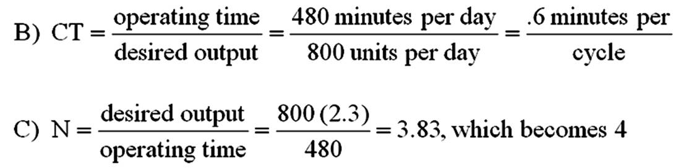  D) Refer to the diagram below.  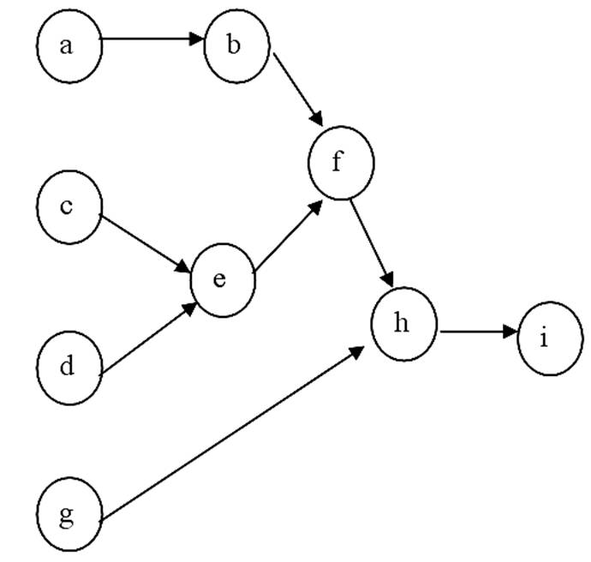  E) See tabular solution below.  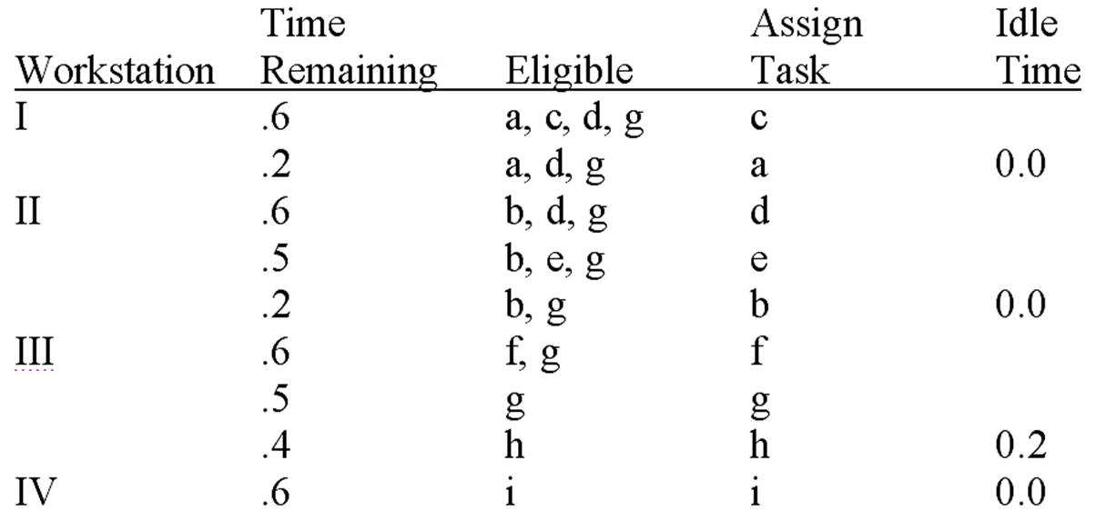  Feedback: Use of this heuristic leads to this solution.

AACSB: Analytic
Blooms: Apply
Learning Objective: 06-08 Solve simple line-balancing problems.
Level of Difficulty: 2 Medium
Topic: Designing Product Layouts: Line Balancing

134. | Given the information below, assign departments to locations in a 3 x 3 grid, with department F in the lower right-hand corner.  Example solution:  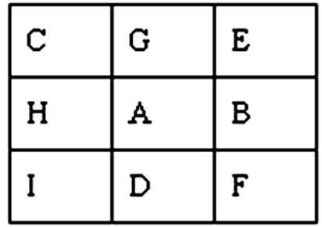  Feedback: Use of location rules leads to this decision. Note how C and F are as far apart as possible.

AACSB: Analytic
Blooms: Apply
Learning Objective: 06-09 Develop simple process layouts.
Level of Difficulty: 2 Medium
Topic: Designing Process Layouts

135. | Given the information below, assign the departments A through I to locations in a 3 x 3 grid, with department E fixed in the lower right-hand corner.  Example solution:  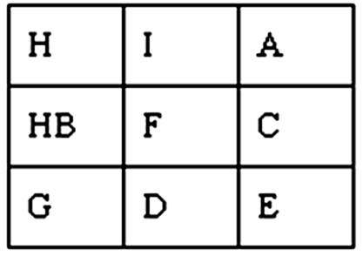  Feedback: Location rules lead to this solution. Note that A and G are well removed from one another.

AACSB: Analytic
Blooms: Apply
Learning Objective: 06-09 Develop simple process layouts.
Level of Difficulty: 2 Medium
Topic: Designing Process Layouts

136. | Determine the minimum number of workstations needed for this situation:  Operating time is 450 minutes per day.  Desired output is 80 units per day.  The sum of task times is 56 minutes.  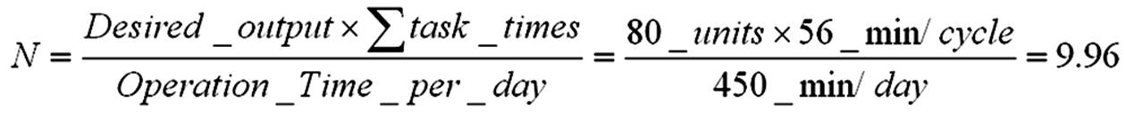  Feedback: Round up to find that 10 stations are needed.

AACSB: Analytic
Blooms: Apply
Learning Objective: 06-08 Solve simple line-balancing problems.
Level of Difficulty: 2 Medium
Topic: Designing Product Layouts: Line Balancing

137. | Given the following data:  Determine the percentage idle time.  (1) Compute the station idle time and the total idle time per cycle:  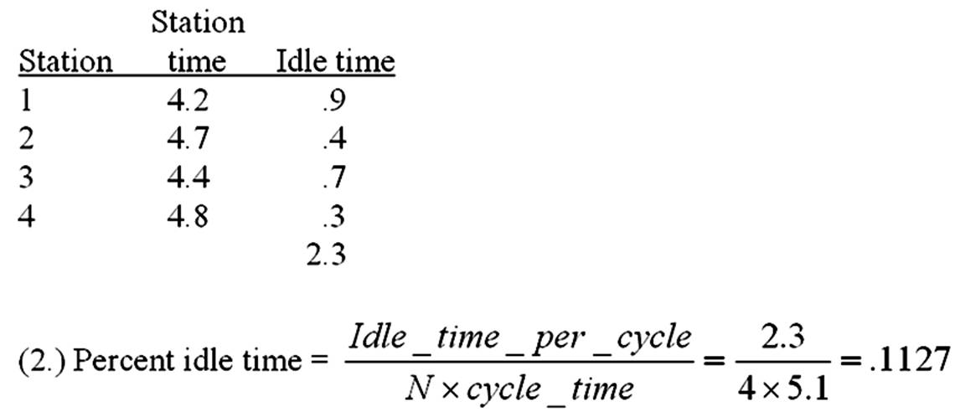  Feedback: With these four workstations, the maximum efficiency is approximately 88.7 percent.

AACSB: Analytic
Blooms: Apply
Learning Objective: 06-08 Solve simple line-balancing problems.
Level of Difficulty: 2 Medium
Topic: Designing Product Layouts: Line Balancing

138. | Given the following process layout data for locating six departments in the six areas shown:  What process layout(s) satisfy(ies) these closeness ratings?  Any layout with I and VI at one end of the facility, III and IV at the other end, and II and V in the middle.  Feedback: I and VI should be close together. III and IV should be close together.

AACSB: Analytic
Blooms: Apply
Learning Objective: 06-09 Develop simple process layouts.
Level of Difficulty: 2 Medium
Topic: Designing Process Layouts

139. | Given the following line balance data:  What is the minimum possible cycle time?  21 seconds  Feedback: The minimum possible cycle time is equal to the longest task time.

AACSB: Analytic
Blooms: Apply
Learning Objective: 06-08 Solve simple line-balancing problems.
Level of Difficulty: 2 Medium
Topic: Designing Product Layouts: Line Balancing

140. | Given the following line balance data:  What is the maximum possible cycle time?  81 seconds  Feedback: This assumes only one workstation.

AACSB: Analytic
Blooms: Apply
Learning Objective: 06-08 Solve simple line-balancing problems.
Level of Difficulty: 2 Medium
Topic: Designing Product Layouts: Line Balancing

141. | Given the following line balance data:  What is the appropriate cycle time for eight hours of operating time per day and a desired output rate of 960 units per day?  30 seconds  Feedback: Divide the desired output rate by the number of minutes available per day.

AACSB: Analytic
Blooms: Apply
Learning Objective: 06-08 Solve simple line-balancing problems.
Level of Difficulty: 2 Medium
Topic: Designing Product Layouts: Line Balancing

142. | Given the following line balance data:  For eight hours of operating time per day and a desired output rate of 960 units per day, what is the minimum number of stations needed to achieve the appropriate cycle time?  Three  Feedback: Divide the total work content by the minimum cycle time.

AACSB: Analytic
Blooms: Apply
Learning Objective: 06-08 Solve simple line-balancing problems.
Level of Difficulty: 2 Medium
Topic: Designing Product Layouts: Line Balancing

143. | Given the following line balance data:  For eight hours of operating time per day and a desired output rate of 960 units per day, what balance (if any) will yield the minimum number of stations?  Station 1: t, v, x; Station 2: u, w, y; Station 3: z  Feedback: This is the only balanced line that features the theoretical minimum number of workstations.

AACSB: Analytic
Blooms: Apply
Learning Objective: 06-08 Solve simple line-balancing problems.
Level of Difficulty: 2 Medium
Topic: Designing Product Layouts: Line Balancing

144. | Given the following line balance data:  For eight hours of operating time per day and a desired output rate of 960 units per day, what is the percentage of idle time for the balance which uses the minimum number of stations?  10 percent  Feedback: Of the total time allocated to these workstations, 10 percent will be idle time.

AACSB: Analytic
Blooms: Apply
Learning Objective: 06-08 Solve simple line-balancing problems.
Level of Difficulty: 2 Medium
Topic: Designing Product Layouts: Line Balancing

145. | Given the following line balance data:  For eight hours of operating time per day and a desired output rate of 960 units per day, what is the efficiency for the balance which uses the minimum number of stations?  90 percent  Feedback: Of the total time allocated to these workstations, 90 percent of it will be occupied.

AACSB: Analytic
Blooms: Apply
Learning Objective: 06-08 Solve simple line-balancing problems.
Level of Difficulty: 2 Medium
Topic: Designing Product Layouts: Line Balancing

146. | Given the following process layout data for locating four departments (A, B, C, and D) in four areas (1, 2, 3, and 4):  What is the distance from area 3 to area 1?  100 meters  Feedback: This information is found in the distances matrix.

AACSB: Analytic
Blooms: Apply
Learning Objective: 06-09 Develop simple process layouts.
Level of Difficulty: 2 Medium
Topic: Designing Process Layouts

147. | Given the following process layout data for locating four departments (A, B, C, and D) in four areas (1, 2, 3, and 4):  What is the total flow between departments B and D?  120 loads per month  Feedback: From B to D there are 70 loads, from D to B there are 50 loads.

AACSB: Analytic
Blooms: Apply
Learning Objective: 06-09 Develop simple process layouts.
Level of Difficulty: 2 Medium
Topic: Designing Process Layouts

148. | Given the following process layout data for locating four departments (A, B, C, and D) in four areas (1, 2, 3, and 4):  If departments A through D were to be located in areas 1 through 4, respectively, what would be the total distance loads would be moved each month?  40,000 meters  Feedback: Multiply the loads conveyed by the distance conveyed.

AACSB: Analytic
Blooms: Apply
Learning Objective: 06-09 Develop simple process layouts.
Level of Difficulty: 2 Medium
Topic: Designing Process Layouts

149. | Given the following process layout data for locating four departments (A, B, C, and D) in four areas (1, 2, 3, and 4):  If department C must be located in area 1, what layout will minimize the total distance loads will be moved each month?  C in 1; A in 2; D in 3; B in 4  Feedback: This minimizes the total distance loads will be moved if C must be in area 1.

AACSB: Analytic
Blooms: Apply
Learning Objective: 06-09 Develop simple process layouts.
Level of Difficulty: 2 Medium
Topic: Designing Process Layouts

150. | Given the following process layout data for locating four departments (A, B, C, and D) in four areas (1, 2, 3, and 4):  If transportation costs are $.25 per load per foot moved, what are total monthly costs for an optimum layout?  $7,000  Feedback: Multiply the total load distance by this cost.

AACSB: Analytic
Blooms: Apply
Learning Objective: 06-09 Develop simple process layouts.
Level of Difficulty: 2 Medium
Topic: Designing Process Layouts

